Counselling at Oxford High School

counselling@oxf.gdst.net
l.healey@oxf.gdst.net h.fenton@oxf.gdst.net
j.talkington@oxf.gdst.net

Counselling is confidential
You can miss lessons to come see us

It’s your time and space to talk about what you want

We’re here to help and support you

Why come for counselling?

People come for lots of reasons, including:
- Friendship issues
- Home life
- Schoolwork and/or exam anxiety
- Relationships
- Gender issues
- Grief
Sometimes it’s easier to talk to someone outside of the situation who is neutral and there just to listen to you.

Outcomes

Types of outcomes people can expect from coming for counselling include:

- Feeling happier
- Feeling more able to cope
- Having working strategies to deal with difficult situations
- More insight into themselves and their motivations

Who are we?
Lucy and Hannah are qualified and experienced counsellors who have worked in schools for a number of years.
Jo Talkington has worked in schools for many years in pastoral roles.

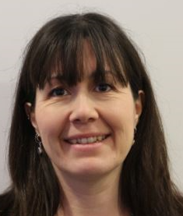
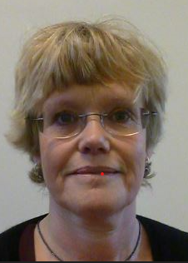

Hannah
Fenton

Lucy
Healey

How to contact us

We work Mondays, Tuesdays, Wednesdays and Fridays. Counselling lasts up to 12 sessions and each session is 50 mins long and takes place in the health centre.

All appointments need to be booked in advance. You can contact us on the counsellors’ email, or you can email the school nurse or speak to her in person. Alternatively do chat to your Head of Year or Form Tutor to make an appointment to come and see one of us.

