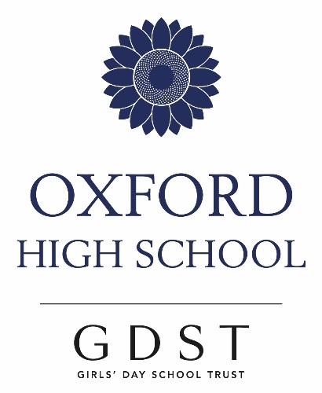

This is OHS Sixth Form
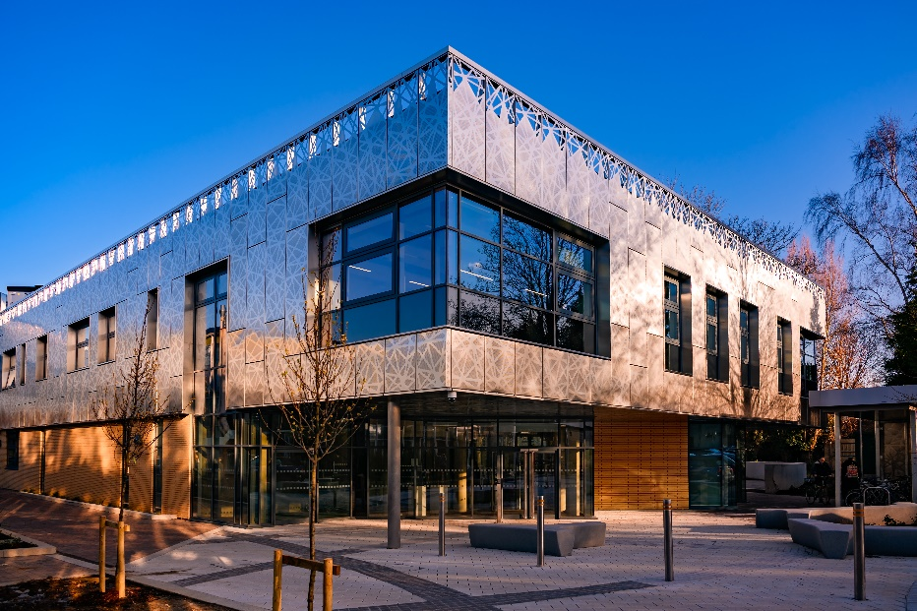 | 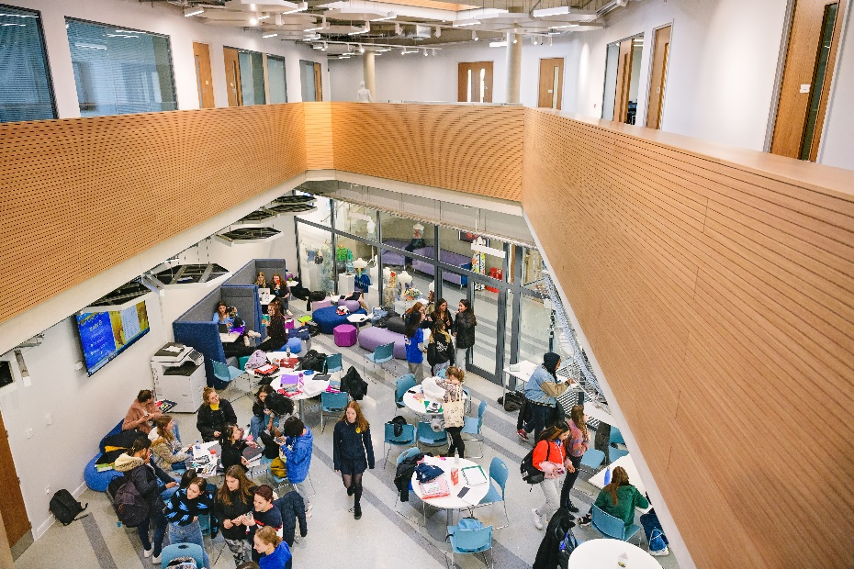
The Ada Benson Building | February 2020

Studying the subjects you love, spending time with your best friends, planning your future, loving the Atrium, leading, chairing School Council, running a company, writing a thesis, meeting academics and experts, making a difference, being ready to take on challenge and change the world…

Most of all, it’s about you and your future.
Where will your Sixth Form journey take you?

Oxford High School has been educating brilliant, fearless and world-changing women since 1875. We are experts in educating high-achieving girls and our Sixth Form programme, the 360 Programme, is designed to give you everything you need for success now and throughout your future careers.
Learn without limits: choose from 25 A-Level subjects including 6 modern foreign languages and new A-Level subjects like Psychology, Economics, Government & Politics. We build the timetable around your choices. Enjoy university-style teaching and learning in lessons.
Challenge: academic rigour and challenge are centre-stage in lessons and beyond. Our results speak for themselves. The Warnock Extended Research Project enables you to pursue your academic interests beyond A-Level with guidance from an expert in that field. OWLS (Oxford and Wimbledon Leading Scholars) is a community of scholars working together and developing their understanding in any number of areas. Our Global Awareness Speaker Programme means you will hear academics and experts and be able to quiz them on their research. Challenge yourself in national competitions and Olympiads, by organising a speaker programme of your own or even your own conference.
Guidance: regular 1:1 conversations with your tutor, our comprehensive Higher Education and Careers programme (including dedicated pathways for success in Medicine, Law and other competitive areas), and our innovative well-being and personal development programme (including our own FutureLearn course) ensure that you have all the guidance and support you need throughout the Sixth Form. We walk alongside you.
Opportunity: develop your leadership through Young Enterprise, Sports Leadership, magazine, Book Buddies and STEM Outreach, running a club or as a prefect or House Leader. Opportunities abound in sport, music, drama, and just about anything else you could wish for too!
Innovation: enjoy dedicated campus-style Sixth Form space. Our ultra-modern Sixth Form Centre, the Ada Benson Building, comes with social space and café, break-out spaces, auditorium and mac suite and a Sixth Form fitness suite which will be located close by.
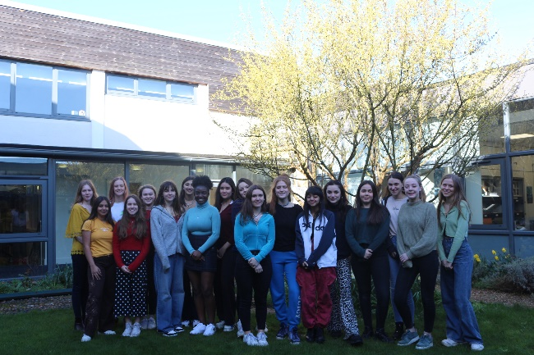
House Leaders, February 2020

This is a GDST Sixth Form
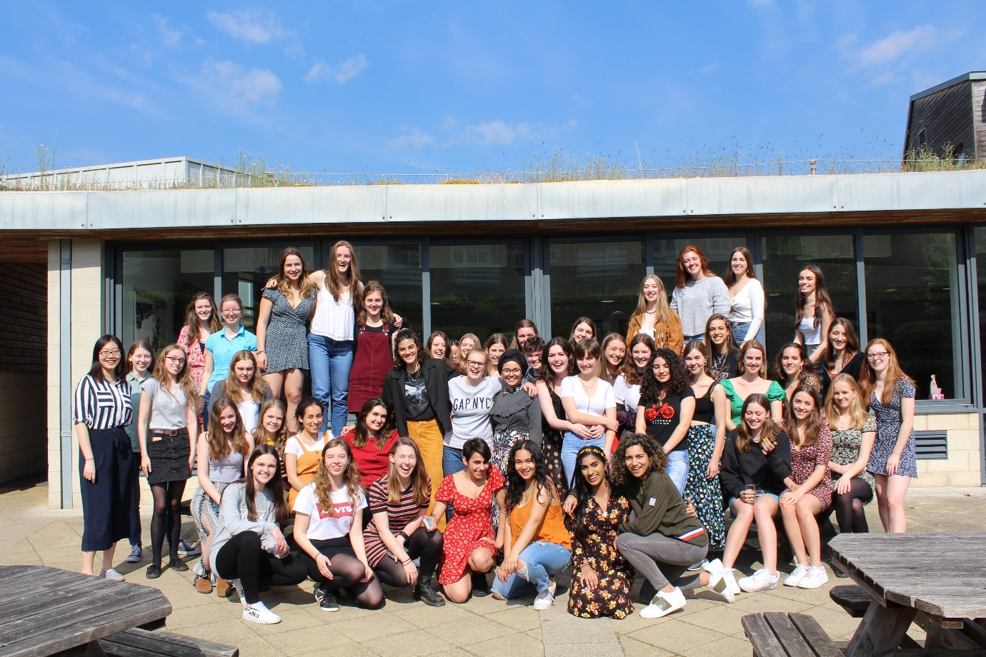2019 Leavers
The GDST is the UK’s largest school network, bringing together 19,000 students and over 70,000 alumnae to ensure that girls learn without limits. Being a Sixth Form student in one of the twenty-five schools in the GDST brings you an outstanding set of benefits and opportunities in Sixth Form and on into your future.
- Mentoring – get information and advice about universities, courses and careers through Rungway, the GDST Alumnae Mentoring App.

- Careers – develop your career through GDST CareerStart workshops or via insight days with prestigious global companies such as Siemens, PwC, Rolls Royce, Deloitte, HSBC and Royal Opera House.

- Leadership – join student leaders from across the GDST at the GDST Young Leaders’ conference, by representing OHS students at the GDST Student Council, or at its Eco Forum.

- GDST at university – prepare for university with pre-interview test preparation courses plus the GDST Oxbridge Programme. Join a GDST alumnae group at your chosen university for a ready-made social scene.

- GDST Life – connect with your peers from across the GDST through the GDST’s own social platform. Find out about Trust-wide events and opportunities, connect with like-minded students through Trust-wide communities and groups, and draw on the wealth of expertise within the Trust through the digital library.

OHS Sixth Form Stats

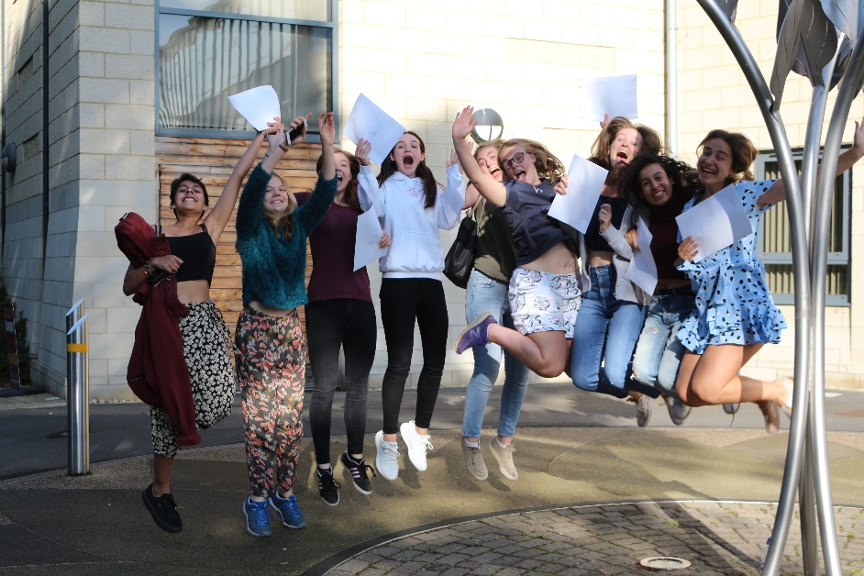

2019 Leavers

OHS is the most consistently successful girls’ school in Oxfordshire and our 2019 A-Level results identified us as the top-performing girls’ school in the country (43.6% A*, 78.8% A* - A).

Our students routinely go to the universities and institutions of their choice, to study the subject of their choice.

On average, 1 in 5 of our university applicants receive offers from Oxford and Cambridge, 1 in 8 students successfully apply to study Medicine and 90% of students receive offers from top Russell Group universities.

Students have also recently achieved places at Ivy League universities (Harvard, Columbia and University of Pennsylvania), at the Dyson Institute (to study Engineering) and at leading institutes for music and the arts.

Talk to us about OHS Sixth Form

Over the past 18 months, our Sixth Form students staged their own plays, went viral with their climate change poetry, released a single, won gold twice at the Chemistry Olympiad, commissioned a new artwork for the school, wrote and published academic journals, mentored students in local primary schools, supported a wide range of charities, secured a global business deal, ran a Green Fair, became Peer Mentors, organised and hosted a Trust-wide conference, led on virtual assemblies and more.
What will your challenge be?

To find out more about OHS Sixth Form contact Miss Pallas-Brown, Director of Sixth Form (r.pallas-brown@oxf.gdst.net) or our Admissions Team at Oxford High School (admissions@oxf.gdst.net)

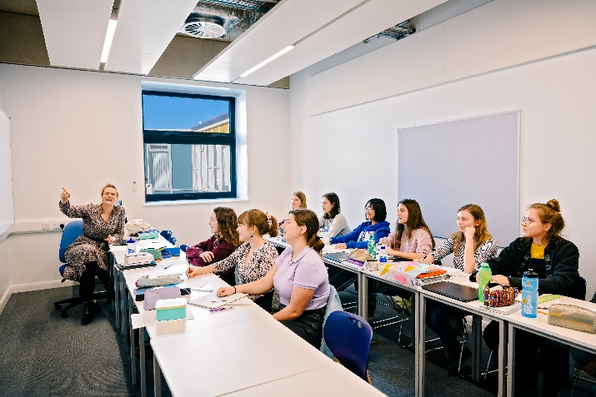 | 