A Level Biology
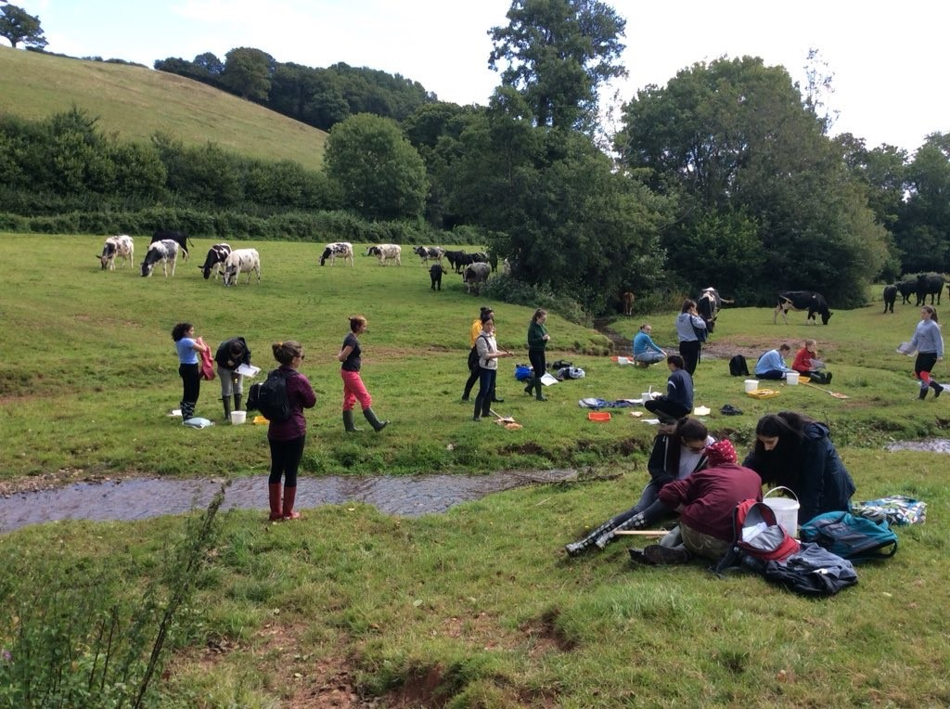
Year 13 conducting ecological sampling of freshwater invertebrates whilst surrounded by a herd of cows

Exmoor National Park, Devon
September 2019

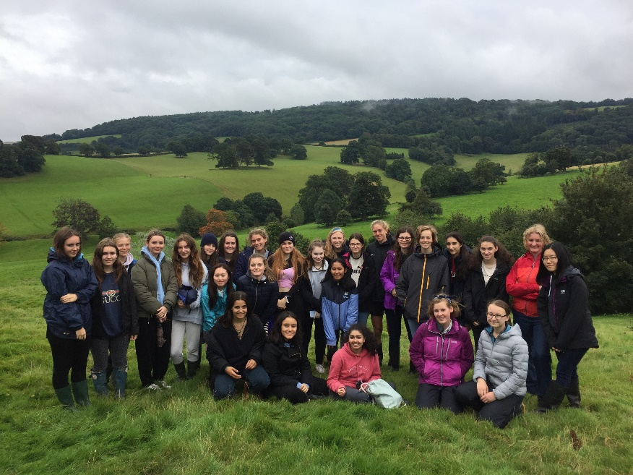
Admiring the view during a nature walk around the grounds of the Nettlecombe Court Field Studies Centre
September 2019

Biology at Oxford High School
Biology is a very popular subject among the Sixth Formers, with approximately 50% of the year group studying for the A Level each year. At OHS, we follow OCR’s Biology A specification (H420). The course is covered by nine periods a week, shared between two teachers.
The course is suitable for anyone with a general interest in Biology, as well as students who are thinking of studying the Biosciences, or a related subject such as Medicine, at university.
The course is built upon experimental investigation, as we believe that students learn best by doing. This will also give you a portfolio of practical work that universities may ask to see as part of your application. You will carry out far more practical work in our department than in any other comparable school and we are confident that the Oxford High School Biology portfolio will be second to none.
The Head of Biology is Miss Zoe Steer. Dr Paul Weeks, Miss Susan Berry and Mrs Maria Whittington also teach A Level. A team of science technicians assists the department and for Biology, this is Ms Ocampo Duque.

Why Study Biology?
Are you a naturally inquisitive person who wants to know more about how living organisms function? Then Biology is the subject for you! If you are inspired by the world around you and often find yourself wondering how our bodies work and why organisms interact with each other, then you are already thinking like a biologist. Biology is a highly respected A Level subject which develops a wide range of transferable academic and practical skills. It is greatly valued by future employers and provides a firm foundation for the study of Biological Sciences, Natural Sciences, Medicine and other related subjects at university. Every year, many of our OHS Biologists continue their studies of Biology and other related fields at top universities including Oxford and Cambridge.

What type of student does this course suit?
Biology A Level will be of interest to you if you are curious about the world around you, from the cellular level, to the whole organism, to the interactions taking place within ecosystems. It is essential if you are considering the study of Medicine, Veterinary Medicine, or Biology-related subjects at university. It combines well with many other science-related subjects including Chemistry, Physics, Maths, Psychology and Geography. To succeed with the study of Biology A Level, you will also need a firm grasp of key mathematical concepts and an interest in carrying out statistical analysis of results. In addition, you will be required to build on your GCSE Chemistry knowledge during topics that focus on Biochemistry. However, most importantly we would like you to study Biology because you thoroughly enjoy the subject and love trying to make sense of the world around you!

Course Structure
Year 12
In Year 12, as well as developing your practical skills you will cover the following modules:
Foundations in Biology
This module provides introductions into cell biology (including microscopy), biochemistry, enzymes, plasma membranes and cell division.
Exchange and Transport
This module explores the need for exchange surfaces and transport systems in plants and animals.
Biodiversity, Evolution and Disease
This module focuses on developing a secure understanding of classification and evolution, biodiversity and communicable diseases.

Year 13
Covid-19 permitting, Year 13 normally begins with a weekend residential to the beautiful Nettlecombe Court Field Studies Centre in Exmoor, Devon. The field trip focuses on developing a range of ecological sampling skills (including bat detecting!) and culminates in the completion of an independent research project.
On our return to school, you will cover the following modules:
Communication, Homeostasis and Energy
This module looks at neuronal and hormonal communication, homeostasis, plant responses, energy for biological process and respiration.
Genetics, Evolution and Ecosystems
In this module, you will learn about the genetics of living systems, patterns of inheritance and variation, manipulating genomes, cloning and biotechnology, ecosystems and populations and sustainability.

Throughout Year 13 you will continue to be exposed to as much practical work as possible. This will include techniques in molecular biology, such as PCR, gel electrophoresis and bacterial transformation. The Biology Department at OHS strongly believes that acquiring the necessary practical skills is as important as the ability to interpret and apply the results. This ensures that our A Level Biologists are thoroughly equipped to succeed with the practical demands of undergraduate courses. Fieldwork, Covid-19 permitting, will be managed accordingly.
Our 2019 Results
A* | 50%
A*-A | 65%
A*-B | 95%
A*-C | 100%

Where do our Biologists go?
The number of OHS Biologists who go on to study Medicine, Natural and Biological Sciences for the past two years is shown below. The number of successful Oxbridge applications is shown in brackets.

Year | Medicine | Natural and Biological Sciences
2018 | 3 | 15 (5)
2019 | 7 | 11 (2)
2020 | 5 | 10 (1)

