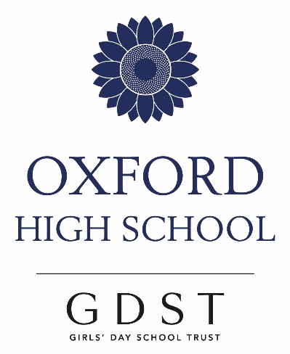
A Level Art and Design: Textiles

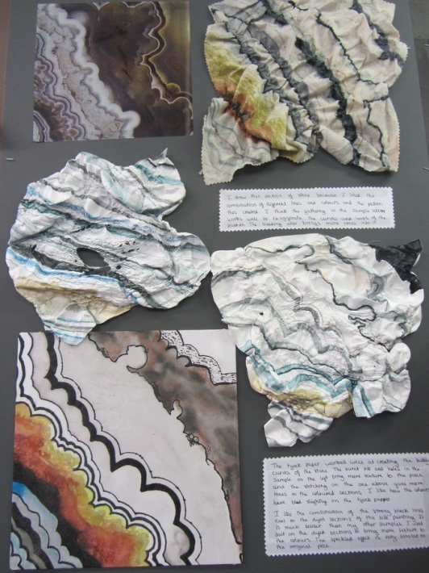

- Could you design the next fashion collection for Topshop or Zara?
- Would you like to create your own fashion label?
- Could you produce the costumes for historical films or a West End musical?
- Do you want to create new designs for printed fabrics, explore new directions in textile fabrics or use fabrics, yarns, stitching and dyes to make a personal, creative response to an issue that inspires you?

If any of these feature in your dreams, then take a first step and study Art and Design: Textiles for A Level
The course is based on a combination of portfolio work and a practical exam where you respond to a selected theme. There are 4 assessment objectives and you will build your studies and investigations around them. You need to:

- Research ideas, collect research, explore sources and make connections with the work of other artists and designers.
- Experiment with materials, techniques and processes to help you develop ideas gleaned from your initial sources.
- Record your inspirations, ideas and developments using a range of observational studies, techniques and processes.
- Resolve your intentions and make a personal response/s.
If you choose to do A Level, you will build a folio of work inspired by a specific title or theme. This will also involve a written essay called a ‘related study’ which investigates a focused element of your project. These two elements will form 60% of your marks.
You will also undertake an Externally Set Task. You will receive a selection of questions in February of the year you complete your course. You will have until Easter to prepare a response to one question, you will then produce your realisation under timed conditions of 15 hours ( the exam element). This work will form 40% of your final mark.
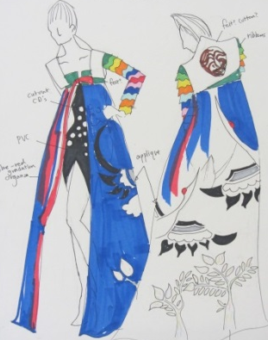
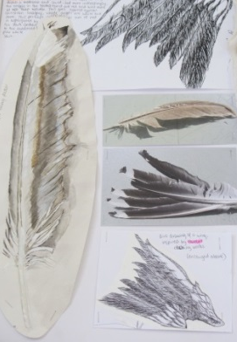
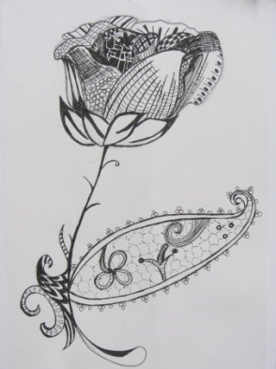
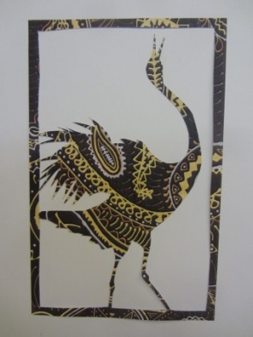
The course is run through a series of workshop activities and experimentation and includes individual interpretation and engagement with a range of approaches and activities. You build your work up through sketch book ideas, developmental worksheets, samples and main pieces.
You will consider the skills, understanding and knowledge required to create original and exciting textile pieces. Think about:
Dyes Stitching Print processes Weaving
Fabrics Construction Artists Designers
Drawing Painting Collage Mixing materials
Colour Texture Pattern Shape
Reviewing Refining Fashion Experimenting
Costume Originality Creative Investigating
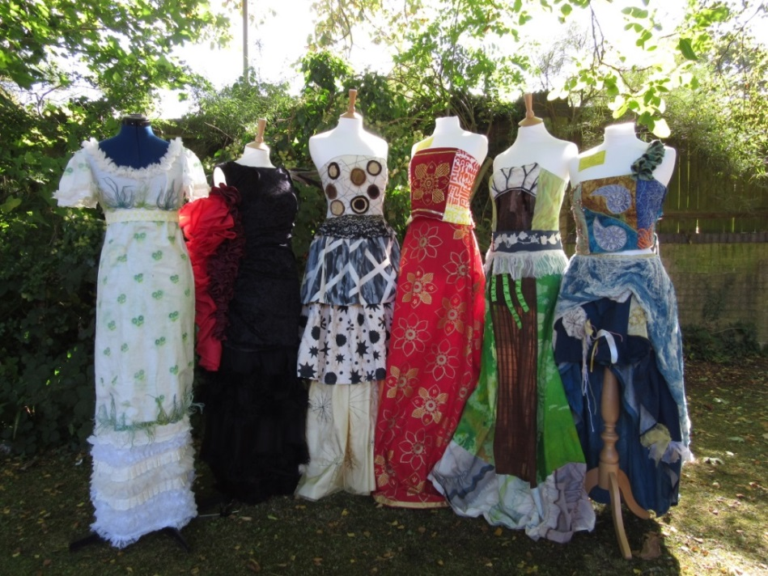

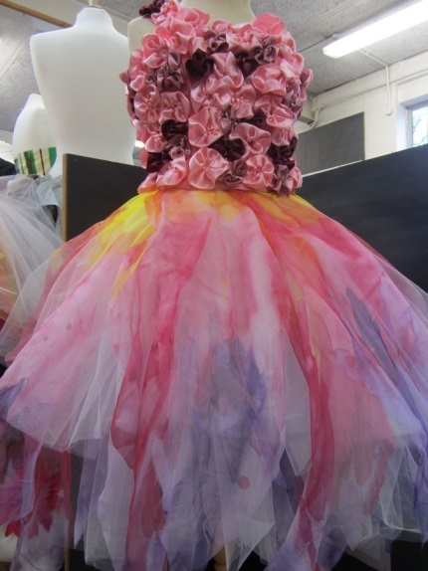
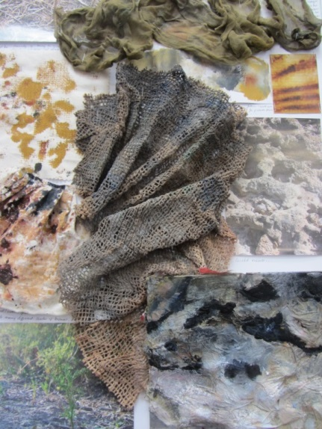
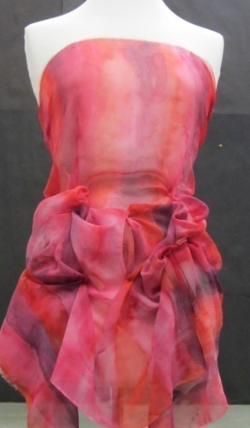

Destinations of past students
In recent years, students taking this course have extended their creative studies on the following degree courses:
Costume and Performance Bournemouth University
Costume Design London College of Fashion, UCA
Theatre Design Central St Martin’s
Animation Bournemouth University
History of Art UCL
Fashion Design Kingston, UCA, London College of Fashion
Fashion Design and Marketing London College of Fashion
Textile Design: printed textiles Brighton University
Textile Design: constructed textiles Manchester Metropolitan
Contour Fashion Leicester University
Foundation Art and Design Oxford Brookes, Banbury College of Art, Manchester Metropolitan
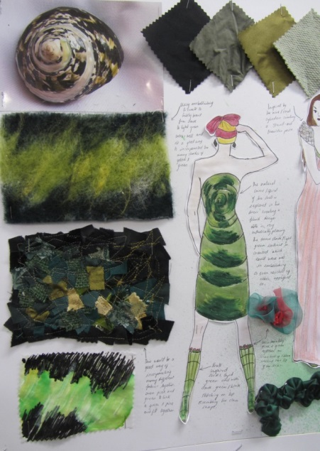

For further details on textile courses please contact Mrs Wilson, Head of Textiles

