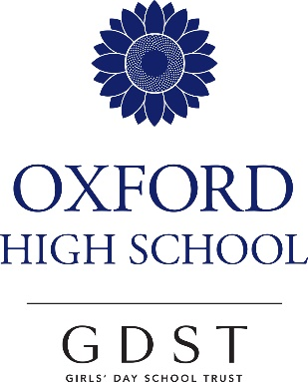

A Level
Religious Studies

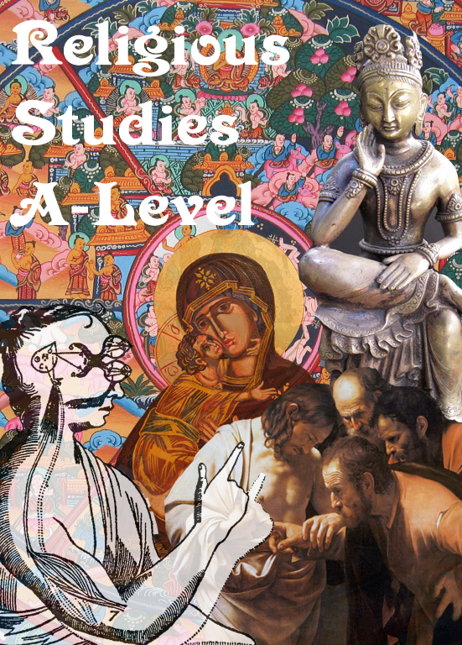

EDEXCEL RELIGIOUS STUDIES - 9RS0

Philosophy, ethics and theology are amongst the oldest of all academic subjects. In days gone by it was the only subject that could be studied at university. Law was then introduced, religious people developed science and, eventually, in the nineteenth century many of our modern subjects began to be taught for degrees. Yet, as we move well into the 21st century the skills developed in philosophy, ethics and theology are still those that employers and universities look for. Skills of analysis, textual criticism, empathy and an ability to clearly express one’s own opinion in order to persuade others of your point of view – these are the things that will give a young person an advantage as they enter the adult world. And, on top of all this, our students will be exploring life, the fundamental and ultimate questions. And it’s fun.

Philosophy, Ethics and Theology

We are really enjoy teaching the new specification that we have been teaching since September 2017. We expect to continue the success that we have had with the previous A Level course. The specification allows us to explore Philosophy, Ethics and Theology. It will be examined by three two-hour papers each with a variety of types of questions. We are particularly pleased with the introduction of academic passages that will allow our academically-minded students to explore and advance their skills.

Philosophy

Philosophy is the love of knowledge or the love of talking. If you are interested in the world around you and like discussion then this is a subject you should be considering. We study one of the pure philosophies in depth: the philosophy of religion. It compliments theology perfectly. The content involves the three major arguments for the existence of God – the Ontological Argument, the Cosmological Argument and the argument from design, problems of evil and suffering, an exploration of religious experience, life after death, critiques of religion and philosophical language.

Ethics

Is war ever okay? Do foetuses have rights? Should men be equal to women? Is it fair that 52% of the population can tell 48% of the population what to do? These are the sorts of questions we look at when we study Ethics. Explore common ground and controversy in dealing with issues that arise in morality: Deontology, medical issues about the beginning and end of life, Utilitarianism, the environment, situation ethics, equality of gender, race and disability, war and peace, Virtue Ethics, natural law and sexual ethics.

Theology

Unique to this A Level, is the opportunity to explore an in-depth study of text. Students who want to go into law, journalism, business or anything where success involves expressing your point of view from a position of strength will benefit from the opportunity to follow a proper academic study of text. We will explore prophecy, the first century Roman/Hellenistic world, philosophical writings like the Prologue in John, the synoptic question and the missing Q, the controversial questions raised in discovering the authorship of John, the crucifixion, scientific and historical responses and possible answers to the question, “why did Jesus have to die?”
The Papers

There will be three examination papers each being two hours long and representing a third of the overall assessment. These will be sat at the end of Year 13.
Teaching

According to national statistics, like many other subjects on offer in our Sixth Form, this subject is amongst the more difficult subjects in which to obtain an A grade. In other words, it is amongst the many recognised academic subjects our students can choose to study.
Our students are taught in such a way as to ensure that all can aim to reach their full potential. Since the introduction of modular courses, called Curriculum 2000, 151 girls have sat our papers, at Oxford High School. Of these, 75 have been awarded UMS marks of 100% in at least one of their modules. The Department really prides itself on providing an environment in which all can succeed.
The Department is led by Mr Packard. He has sat on national committees advising all schools on the best ways to teach Sixth Form Religious Studies, and has sat on the National Subject Panel for A Level Religious Studies. While acting as a consultant to that panel, Mr Packard drafted the grade descriptions that all A Level Religious Studies students are assessed against. He currently sits on the OCR Religious Studies Forum. He was for many years an A Level examiner and INSET trainer for EDEXCEL.
Miss Pallas-Brown is an Oxford graduate, who is also Assistant Head: Director of Sixth Form.
Mrs Townend is an Oxford graduate, who completed her PGCE at Cambridge University.

Destinations of our students (since Curriculum 2000)

Critical and Academic

Religious Studies (Ethics, Philosophy & Theology) is a rigorous and thought-provoking subject. The subject teaches you how to critique material and form well-developed and reasoned arguments in both verbal and written forms.

Highly Relevant

“Religion is playing an increasingly important role in state politics, international relations, and social actions. The fostering of religious understanding has immense implications for individual, national and international well-being. By developing your knowledge of religions you will take valuable skills into whatever career you choose”. (University of Cambridge)

What can I do with Philosophy, Ethics and Theology?

“Be a nun”. Well yes, you could go into the Church and we have one former student who intends to do just that. However, when Mr Packard studied Religious Studies, at university, only one of his 44 contemporaries went into the Church.

The University of Cambridge tells us that, in 2014, over 40% of their Theology and Religious Studies graduates went on to further study, teaching or law.
51% went into professional or managerial roles within six months of graduation, many in the financial services industry. (outreach@divinty.cam.ac.uk)

The subject and Higher Education entry

The Russell Group of top universities has made it clear that this A Level provides ‘suitable preparation for University generally’.
Both Oxford and Cambridge University include this A Level in the top level list of ‘generally suitable Arts A Levels’.
Applicants with this A Level were more likely to gain admission to study History at Oxford University in 2012 than those with A Levels in many ‘facilitating’ subjects.
20% of students admitted to Oxford University to study mathematics in 2011 had a Religious Studies A Level (more than those with Economics, Physics and Business Studies A Levels).
Source: NATRE, 2014

FUTURE CAREERS

Below are examples of where former students, of this Department, are today.

(2000) Senior Lawyer at Foreign and Commonwealth Office

(2003) Head of Social Housing Policy at Ministry of Housing, Communities and Local Government

(2004) Actor, roles include, Mutual Friends (2008), Waking The Dead (2009), Wallander (2012) and The Huntsman: Winter’s War (2016)

(2005) Anaesthetist

(2005) Associate Director, Tenco Blue Ribbon (reputation consultant, worked with Instagram, Facebook, RBS, RNLI)

(2006) Archaeologist.

(2006) Senior Consultant, Policy and Evaluation Unit at Ipsos MORI

(2006) Account Director at Just So London

(2009) Head of Apprenticeship Strategy at Department for Education

(2012) Winner of Cambridge University’s Teape Prize (for her work on Indian religions)

Collage by RS A Level student (2014-2016)

