A Level Psychology
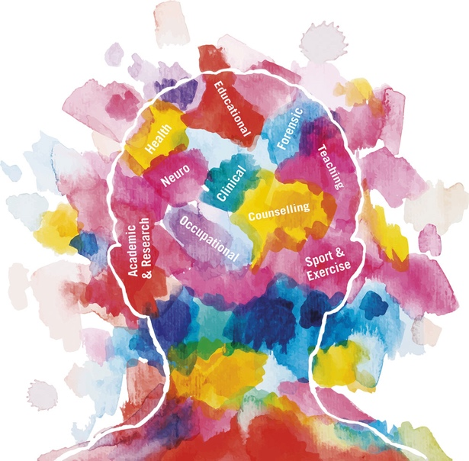

What is Psychology?
Psychology is the scientific study of people, the mind and behaviour.

This booklet contains details of what Psychology is all about, and tries to answer some of the questions that you might have about taking the subject at A Level. Are you interested in the psychological processes, are you curious about how our mind works, have you thought about how behaviour is shaped and what role the environment plays in our everyday life? These are some of the issues that are often explored in Psychology. It’s a fascinating science with cutting-edge research that has real world applications that you are bound to find interesting. Why choose Psychology, what the course offers and where it can lead you are some of the questions we have tried to answer, and hope the information provided can help you decide that Psychology is the subject for you. If there are further questions, please feel free to get in touch with the department.
Patricia Dass
Head of Psychology
Oxford High School, September 2020/21

Is Psychology a “new” subject?
Why people do the things they do is an age-old question. The roots of modern Psychology go back to the ancient Greek Philosophers in the 5th and 4th centuries BC. However, Psychology—the science concerned with behaviour—only became established as a discipline in its own right around 135 years ago. One of the exciting things about this is that the studies and theories that you will be learning about are relatively new, and textbooks will often include studies that have only been conducted in the last few years.

Who should study Psychology?
Psychology is a subject that suits scientists, history students and, particularly, “all-rounders.” Psychology has been a science A-level since Sept 2008, and the discipline of Psychology involves investigating issues by carrying out studies and experiments; the data collected need analysis and interpretation, and there is frequently debate as to how to interpret findings. This can attract students who enjoy thinking about alternative theories and interpretations, questioning “evidence” and addressing more philosophical questions for which there may be more than one correct answer.
- Does prison really change criminal behaviour?

- Why do some people conform more than others?

- Does childhood attachment type influence later life?

The A Level Psychology students taught in the past have taken part in activities as diverse as collecting data on short-term memory recall, using biofeedback to measure their stress levels, conducting their own research studies and having a debate on whether attending day care has any effect on children’s development.
A Level Psychology students need to read about (and carry out some small-scale) scientific studies. They need to enjoy discussing topics, challenging findings, thinking about alternative theoretical explanations and expressing their ideas in the form of written arguments. Above all, they need to be interested in behaviour and have a desire to study a subject with strong links to Biology.
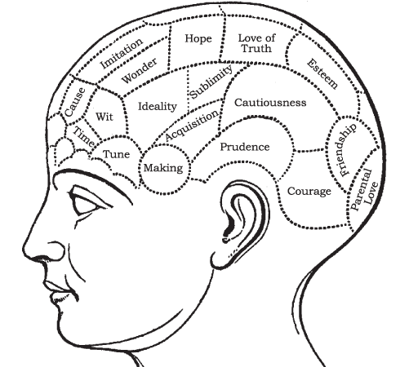
What topics are covered in A Level Psychology?

PAPER 1: Introductory topics in Psychology
- Social Psychology (Why do people conform? When and why do people obey authorities? Why do some people choose not to conform?)
- Cognitive Psychology (Memory: How do we remember? Why do we forget? What affects the accuracy of eyewitness testimony?)
- Developmental Psychology (Attachment: the relationships that children form with parents and those around them)
- Psychopathology (What kinds of behaviour are considered “abnormal”? Why do they occur? Can they be prevented or treated?)

PAPER 2: Psychology in Context
- Approaches in Psychology (Origins of Psychology, Cognitive, Biological, Behavioural, Psychodynamic and Humanistic, comparison of Approaches)
- Biological Psychology (the fight or flight response, the function of the endocrine system: glands and hormones. Localisation and function of the brain, plasticity, ways of studying the brain)
- Research Methods (including ethical issues, designing studies, analysing and presenting quantitative & qualitative data)

PAPER 3: Issues and Options in Psychology
Issues & Debates in Psychology (compulsory)

And one topic from:
- Relationships/Cognition & Development/Gender
- Schizophrenia/Eating Behaviour/Stress
- Aggression/Forensic Psychology/The Psychology of Addictive Behaviour

- The topics highlighted above are what we have chosen to explore in OHS.

What exams are there?
The specification that we follow at Oxford High School is AQA. We’ve summarised course details in this booklet, but further details can be found at AQA exam board website: http://www.aqa.org.uk/subjects/psychology.
The exams take place at the end of the A-level course, and consist of structured compulsory questions, including short answers, stimulus material and longer questions requiring more extended writing. Each paper counts for 33.3% of the A-level.
There is no assessed coursework component.

What skills will I develop?
Psychology A Level will enable you to:

- Select, organise and communicate relevant information in a variety of forms.
- Analyse and evaluate scientific knowledge and processes
- Apply knowledge to unfamiliar situations
- Assess the validity, reliability and credibility of scientific information.
- Describe ethical, safe and skilful practical techniques and processes
- Know how to make, record and communicate reliable and valid observations and measurements with appropriate precision and accuracy
- Analyse, interpret, explain and evaluate the methodology, results and impact of experiments and investigations in a variety of ways.
- Recall and understand the major approaches in Psychology
- Appreciate issues and debates related to each of the topics studied (e.g., ethical issues, culture and gender bias, nature-nurture debate, etc).

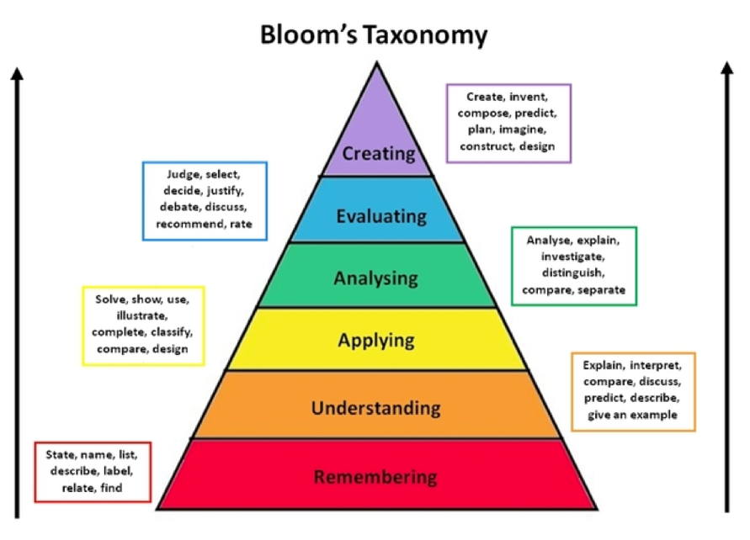

What other subjects go well with Psychology?
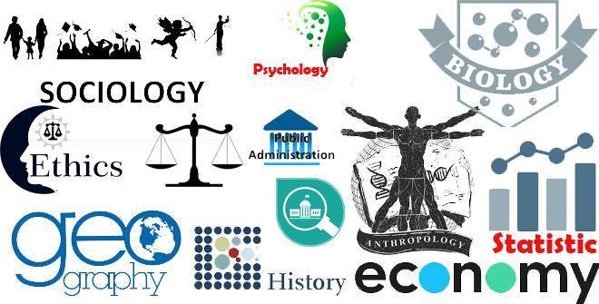
Psychology will complement just about any other subject. You can take Psychology A-level alongside any other A-levels, there are no other subjects that you “ought” to take with Psychology. Sciences help with the scientific approach to examining behaviour, Humanities subjects help with essay writing and forming arguments, Maths helps with analysing data… If you were to go on to study Psychology at University, Biology would be very helpful, but it is not essential.

Who teaches Psychology?
The subject is taught by Ms. Patricia Dass who is Head of the Psychology Department. She has completed her M.Sc. in Educational Psychology and has been in the education field for more than 23 years both in the UK and overseas. Apart from being a Psychology teacher, she is also involved in research groups with various NHS research teams. She has also been an examiner for some years.
How can I find out more about Psychology?
Try out the many fun Psychology tests at the BBC and Psychology Today websites (and think about how much you can “trust” simple tests like these):

They include:
Perfectionism - Do your friends tell you you're fussy and meticulous? Find out if you're a perfectionist. http://psychologytoday.tests.psychtests.com/take_test.php?idRegTest=3262
Art and Personality - Is there a connection between your personality type and the art that you like?
Who do you think you are? This psychology test scores you on five aspects of your personality. http://psychologytoday.tests.psychtests.com/take_test.php?idRegTest=1297

- Talk to the current Sixth Form students or the Head of Department, Ms. Dass
- Come along to Psychology Club.
- Read more about Psychology. Here are some suggestions of short accessible books (in the library) that you might enjoy:

    - The Tipping Point: How Little Things Can Make a Big Difference by Malcolm Gladwell
    - Blink: The Power of Thinking Without Thinking by Malcolm Gladwell
    - The Curious Incident of the Dog in the Night-time by Mark Haddon
    - The Man Who Mistook His Wife for a Hat by Oliver Sacks…and many more

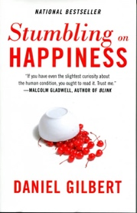
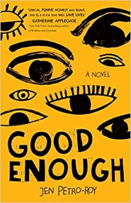
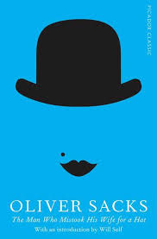
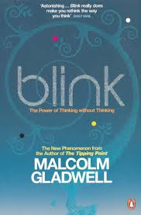

- Read this month’s “Psychology Review” magazine in the Library
- Look at some of the topics in the A Level Psychology books in the Library, or borrow an A Level text book from the Department.
- Find out about Psychology at some of the following websites:
    - British Psychological Society [http://www.bps.org.uk/]
    - Simply Psychology http://bit.ly/15fKTYa
    - American Psychological Association [http://www.apa.org/]

Why Study Psychology at Oxford High School?

At Oxford High School, we have chosen a specification that closely matches the key areas of Psychology that are studied at University level (see British Psychological Society website). Our course focuses on studies and evidence and, within the course, we have selected the topics that are most evidence-based and relevant to psychologists today.
However, choosing to study Psychology at Oxford High School is much more than just taking the A-level. We have a wide range of co-curricular events, talks and opportunities on offer, Covid-19 permitting. Here are some of the events that the OHS Psychology Department has held over the last few years:
- Visit to the Department of Experimental Psychology at Oxford University providing students with a chance to experience a real research setting by taking part in a study of perception of time and attend MSc Poster Presentations.
- Visit the Brain Network Dynamics Unit at Oxford University, attending talks and workshops on the use of neural aspects of memory, the use of animals in research as well the synaptic plasticity in the brain.
- Sixth Form Psychology conferences involving lectures and smaller workshops with psychologists on a range of topics.
- Psychology Film Nights (relaxed evening watching and discussing a recent movie with a psychological theme).
- Psychology Reading groups (we have for example read and discussed “Stumbling on Happiness,” “Outliers” and “Bad Science” and the ‘Psychopath test’).
- Psychology club with sessions varying from practising “Offender Profiling” and discussion about “the Criminal Mind” to measuring stress levels with a GSR monitor!
- Invitations to the Mind and The Brain workshops at St Hilda’s College focusing on Psychology and Depression, Addiction and Dreaming.
- GDST Psychology Essay Competition.

What might studying Psychology lead to?
Almost anything! Psychology has a big impact on all aspects of public life, particularly in areas such as education, health, the economy, industry and social justice.
Here are just some of the degree courses that Oxford High School Psychology students have gone on to study at University over the last few years:
Psychology (Birmingham, Edinburgh, Cardiff, Leeds, Oxford, Cambridge, Nottingham, York, Royal Holloway, Warwick, UCL); PPSIS (Politics, Psychology, Sociology and International Studies, (Cambridge); Geography (Cambridge, Leeds); History (York, Birmingham); Law (Exeter, Warwick); Religion and Theology (Bristol, Manchester); Biomedical Sciences (Manchester), Medical Sciences (Leeds); Modern Languages (Durham); Anthropology (UCL, Bristol); International Relations (LSE), Journalism, Media and Sociology (Sheffield); Criminology (Leeds, Sussex, Manchester); Business/Industrial Economics (Nottingham, Westminster); Biochemistry (UCL); English (Bristol, Edinburgh, Leeds); Human Sciences (Durham); Philosophy (Reading, Durham)…
They vary from careers directly related to Psychology (Clinical Psychology, Occupational Psychology, Educational Psychology, Research career) to professions such as Law and Accountancy, to careers in Management Consultancy, NHS Human Resources and Medical publishing, to advisors to major charities, pharmaceutical companies, mobile phone companies and industry.

Do I need to take A-level Psychology if I want to read Psychology at University?
To read Psychology at University “you will need to be able to handle scientific concepts, to be numerate and to have good writing skills…” (BPS website; careers advice). These are skills that A-level Psychology will foster. You do not necessarily have to have taken A-level Psychology in order to read the subject at university. Having said this, undergraduates reading Psychology at degree level have often studied it at A-level. It may give you a “headstart” when you start your Psychology degree (BPS website) and past students have fed back to us that they feel this is definitely the case. Of course, Psychology A-level also provides you with insight into the subject and helps you decide if you would be suited to studying it at degree level, something which admissions tutors will be very keen to ascertain!

Quotes from students at Oxford High School who have taken A-Level Psychology
“If you’re the kind of person who catches themselves wondering why people act the way they do, Psychology is a great subject for you to take”
“What I like most about Psychology is the discussion we have in class”
“You have to work hard but you learn about really interesting aspects of the human mind”
“Psychology really pushes your analytical and thinking skills”
“It is so interesting and relevant”
“Psychology goes well with my two other subjects, Biology and RS. At one stage I was learning about the brain in all three subjects!”
“It’s such a fantastic subject and really broadens your mind”
“Psychology gives you a very good starting point for so many different subjects, as the topics covered are so varied, most of which we can relate to”
“You have to be prepared to do a lot of work, and I find it the most difficult out of all my subjects”
“I found there were many aspects of other subjects in the psych course, such as Maths and Biology, and I sometimes found it a bit like Philosophy”
“Although you don’t learn how to analyse people in your class, I find Psychology a fascinating subject. You do need to remember a lot of facts and figures, but you also get to do your own experiments (which is great)”
“I think something I’ve definitely learned in Psychology was not to take everything at face value, and that there is rarely one reason for something”

Great websites to help you at any level
WEBSITES
- https://www.bps.org.uk/public/become-psychologist
You can find out just what types of careers are available in Psychology by accessing the British Psychological Society’s careers website.
- http://www.aqa.org.uk/subjects/psychology/as-and-a-level/psychology-7181-7182/specification-at-a-glance

The purpose of psychology is to give us a completely different idea of the things we know best.
Paul Valery

