A Level Physics

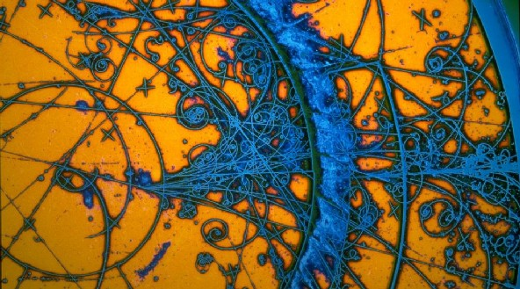
“Education is not the learning of facts, but the training of the mind to think”
Albert Einstein

“Anyone who claims to understand Quantum Mechanics is either lying or crazy”
Richard Feynman
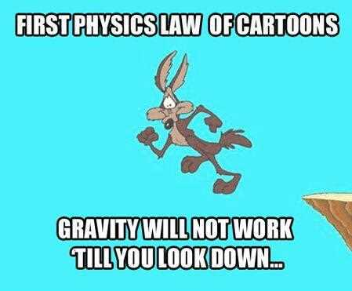

Welcome to the Physics Department
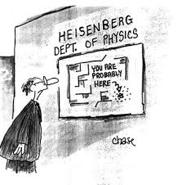
Physics at OHS is challenging, rewarding and fun. To be a successful physicist, you will need to be resilient, intelligent, a strong mathematician, dexterous in your use of complex equipment, curious and determined. If this sounds like you, read on!
The AQA A-level Physics course lasts two years, with formal exams at the end of the second year.

The first year of A Level:

- Measurements and their errors
- Particles and radiation
- Waves
- Mechanics and energy
- Electricity

Second year of A Level:

- Further mechanics and thermal physics
- Fields
- Nuclear physics
- Option topic (which will be chosen, by class vote, between Astrophysics, Medical Physics, Engineering Physics, Turning Points in Physics)

Practicals

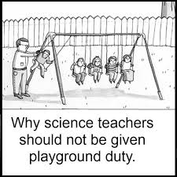
Physics, like all sciences, is a practical subject. In the AQA course, there are 12 core practicals which you must do (although we do lots more) in order to gain full experience of the techniques and equipment expected of an A Level student. Successful completion of these experiments will lead to the award of the Practical Endorsement, which is a separate award to your Physics A Level.

Throughout the course you will carry out practical activities including:
- investigating interference and diffraction of laser light
- measuring acceleration due to gravity
- investigating systems that oscillate
- investigating the links between temperature, volume and pressure
- safe use of ionising radiation
- investigating magnetic fields

Exams

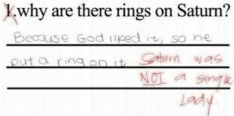
There is no coursework in the AQA A Level. However, your performance during practicals will be assessed as described above. There are three exams at the end of the two years for A Level, all of which are two hours long.
At least 15% of the marks for A-Level Physics are based on what you learned in your practicals. A Level Physics builds on the work done in GCSE Science and Maths, so you should have very good GCSE results from both. Written communication is also important, so you will need to be able to express your ideas clearly and concisely using technical language.

Physics results at A Level at OHS

The school has enjoyed a national reputation throughout its long history. Academic standards and results are exceptional, with the clear majority of the grades A* or A year-on-year.

What other subjects work well with Physics?

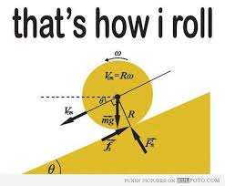

This is what makes the Sixth Form so exciting. Physics goes well with a range of subjects. Many students study it alongside Mathematics, Chemistry, Biology and Religious Studies (an excellent combination) as well as Economics, Music, Latin, German, Computer Science and English. In other words, it compliments virtually every subject offered at Oxford High.

Although the course is designed to be done without the need to choose any other specific A Level subjects, we do recommend that Physics is taken alongside Mathematics. If you plan to take Physics further, maths skills are essential and become more and more important as you progress. Do speak to a member of the Physics Department if you would like more advice.

Where do Physicists go to university?

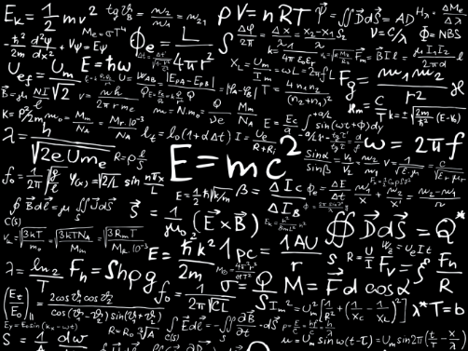
Students choose a range of top universities to study Physics and very often Engineering, in a range of disciplines. Medicine and Natural Sciences are popular choices.

Typical destinations include Cambridge, Oxford, Imperial College and Durham.

