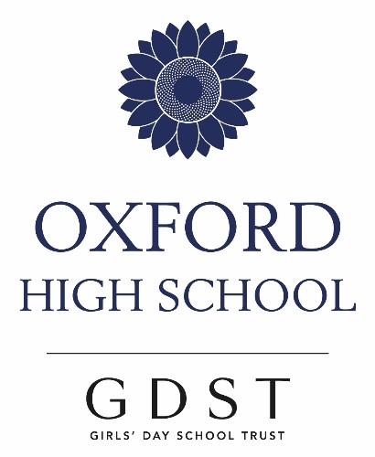

Music at
Oxford High School

We aim to foster a lifelong love of music through academic study and performance

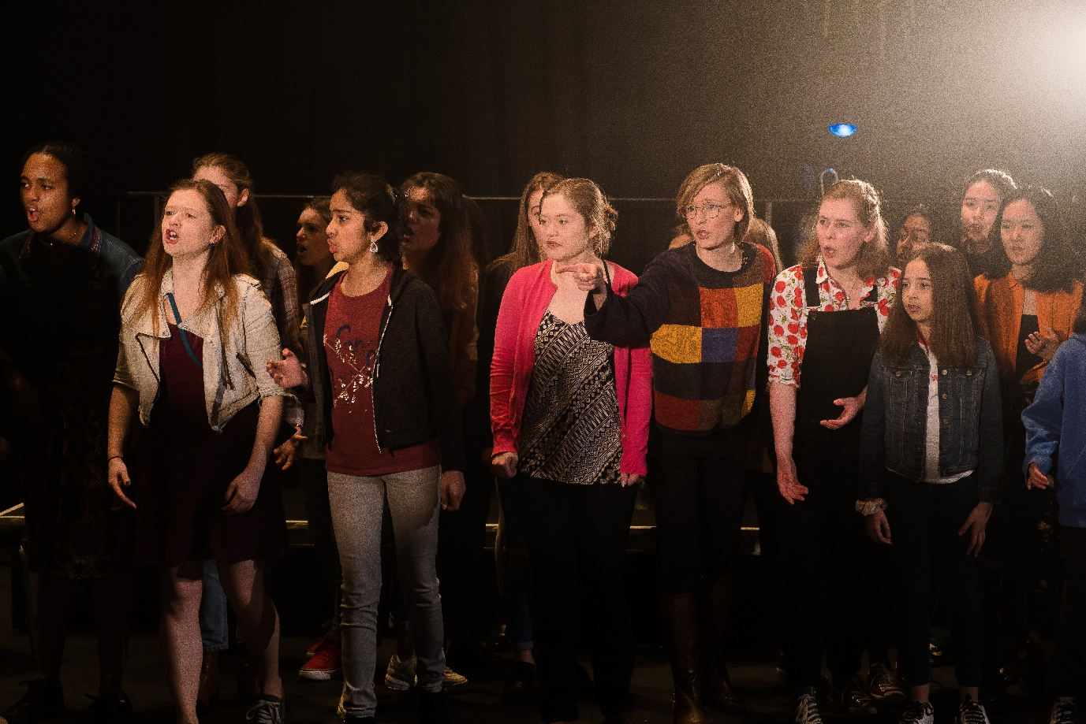

The Music Department comprises:

- Peter Foster – Director of Music
- Andrew Jarvis – Assistant Teacher
- 23 Visiting Music Tutors
- Luci Brooks- Administrator

Accommodation in the Music School includes two classrooms, one equipped with sixteen computers and keyboards, a recital room which houses a Steinway Model B concert grad piano, and eight practice rooms.

Individual Music Lessons
Covid-19 permitting, these take place in study periods, at lunch times, before or after school. Studies include: piano, singing, violin, viola, cello, double bass, flute, oboe, clarinet, bassoon, saxophone, trumpet, French horn, trombone, percussion (orchestral or drum kit), harp, classical guitar, electric guitar, recorder.

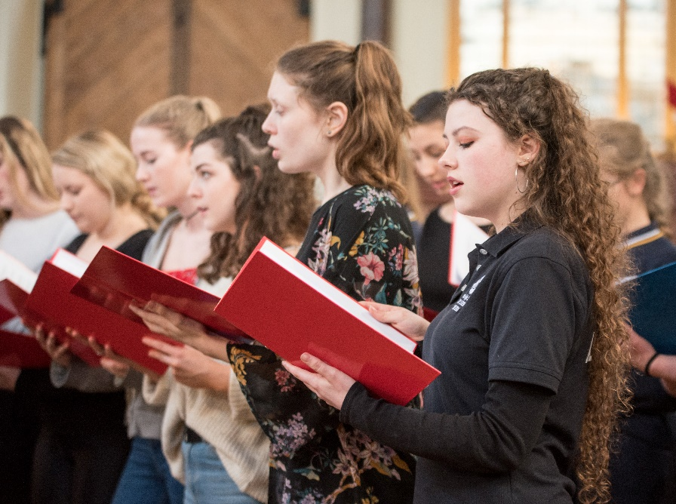
Scholarships and Exhibitions
All OHS scholarships are awarded on merit and independently of parental income. Details of how to apply for a scholarship will be sent out once your daughter has received the offer of a place. In auditions, applicants are asked to perform two contrasting pieces of Grade 8 standard or above and to talk about the music in their lives. Award holders are expected to show leadership in school music, contribute strongly to school ensembles including helping to direct them, and receive solo opportunities in high-profile concerts.

Do apply – we would like to hear you!

Oxbridge Applications

We can offer specialist tuition for the music courses and choral and organ awards entrance tests.

Cambridge Pre-U Music (Cambridge International Examinations)

We offer the Pre-U Principal Study in Music as our Sixth Form option in Music. This is a level 3 academic qualification (like an A Level). Like Music A Level, there are three main strands of study, performance, composition, and the historical and analytical study of music. We feel this course is well suited to Oxford High pupils because:

- It offers excellent scope to stretch and challenge the most able musicians in the areas that particularly interest them.
- The syllabus content is coherent and focused, with a good balance of breadth and depth.
- The course emphasises topics which fit well with musical interests and skills a lot of our pupils possess, as well as introducing them to unfamiliar music.
- The course is designed and recognised as an excellent foundation for the academic study of all subjects, not just Music.

Component 1: Listening, analysis and historical study (30%)

- Core topics: symphonic and orchestral music in the 18th and 19th centuries.
- An optional topic relating either to music from the Renaissance or Baroque period, or music in the 20th and 21st centuries.
- Two exam papers (1h 30 mins each), one short-answer listening paper, one essay paper.

Component 2: Performance (22.5%)

- 15-20 minute recital on your main instrument (grade 7 standard or above).
- A further performing skill chosen from: ensemble performance, performance on a second instrument, improvisation.
- Examined by a visiting examiner in a live performance.

Component 3: Composition (22.5%)

- Exercises in two different disciplines in harmony and counterpoint (coursework and final exam).
- A composition to a brief set by the exam board (coursework), guide length 4 minutes.

Component 4: Personal study (25%)

- Your own choice from: a dissertation (3,500 words maximum) on a musical topic that interests you; an extended recital (25 minutes); two additional compositions; a music technology project.

Senior School Concert
Oxford Town Hall
November 2018

Performing Groups

There is a performing group for you, whatever your ability and musical tastes!

Senior Orchestra – a full symphony orchestra comprising around 50 players. Recent performances include Beethoven’s Eroica Symphony, Vaughan Williams’ English Folk Song Suite, and highlights from Les Mis.

String Orchestra – a group of around 20 advanced players. Sometimes, this group is also joined by advanced wind or brass players to form a chamber orchestra. Recent performances include Holst’s ‘St Paul’s’ Suite the 3rd and 4th Brandenburg concerti, and Vaughan Williams’ Fantasia on Greensleeves. This group often accompanies concerti or choral performances in school concerts.

Concert Band – a group which is led by Sixth Formers for advanced wind, brass and percussion players, which plays an eclectic and entertaining range of music.

Senior Choir – a large, unauditioned group for all those who enjoy singing. They are sometimes joined by guest tenors and basses. Recent performances include Carl Orff’s Carmina Burana, Holst’s Hymns from Rig Veda, a fully staged production of Purcell’s Dido and Aeneas, and a selection of Sinatra hits.

A Cappella Choir – an auditioned choir for advanced singers specializing in more challenging music. They sing a range of musical styles both with and without accompaniment. Major works performed recently include Pergolesi’ Stabat Mater and Haydn’s Nelson Mass, as well as shorter choral pieces from the middle ages to the 21st century.

Chamber Groups – good instrumentalists are encouraged to form chamber groups, and are given as much help and coaching as they need

Musicals

Collaborations with the Drama Department are a major feature of our activities – our singers take on dramatic roles and our instrumentalists form the band. There are two productions each year - a Senior School and a Lower School musical.

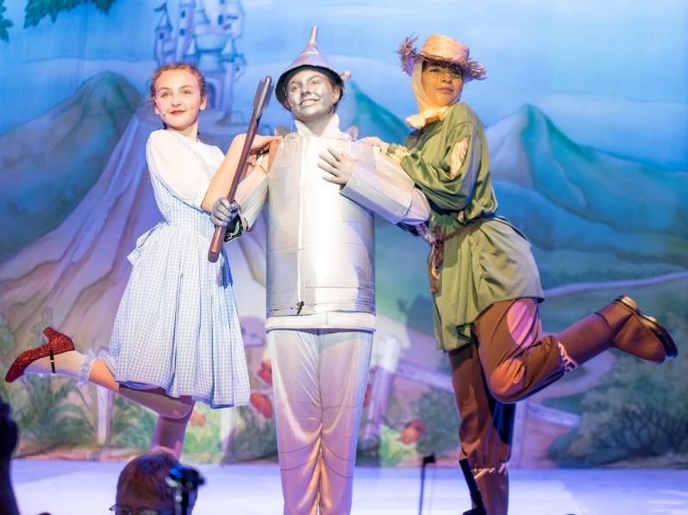
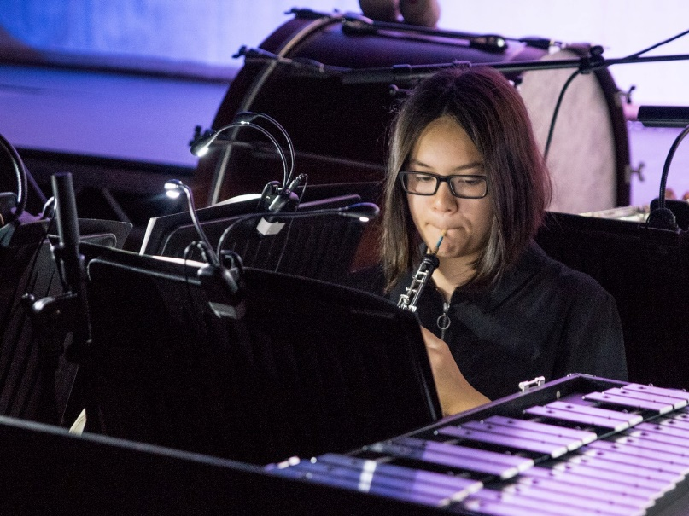

Concert Schedule

Covid-19 permitting, we run a busy concert schedule providing opportunities to perform in Oxford’s beautiful and inspiring venues. The concert calendar includes:

- Major Senior Concert in external venues in Oxford. These include the Sheldonian Theatre, the University Church, Oxford Town Hall, Merton College Chapel, St. Barnabas Church, The Holywell Music Room
- A Sixth Form concert (planned and run by students) in the Music School Hall
- Lunchtime Concerts in school
- Open Mic nights
- Our annual Carol Service, taking the form of the traditional Nine Lessons and Carols, in the local church of St. Andrew’s
- Opportunities to perform more widely outside school. We have recently collaborated in two professional productions with Oxford Opera, in which our students formed part of the chorus

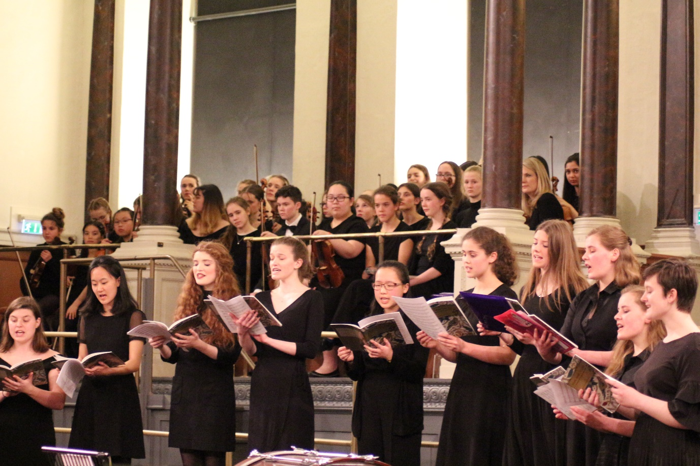

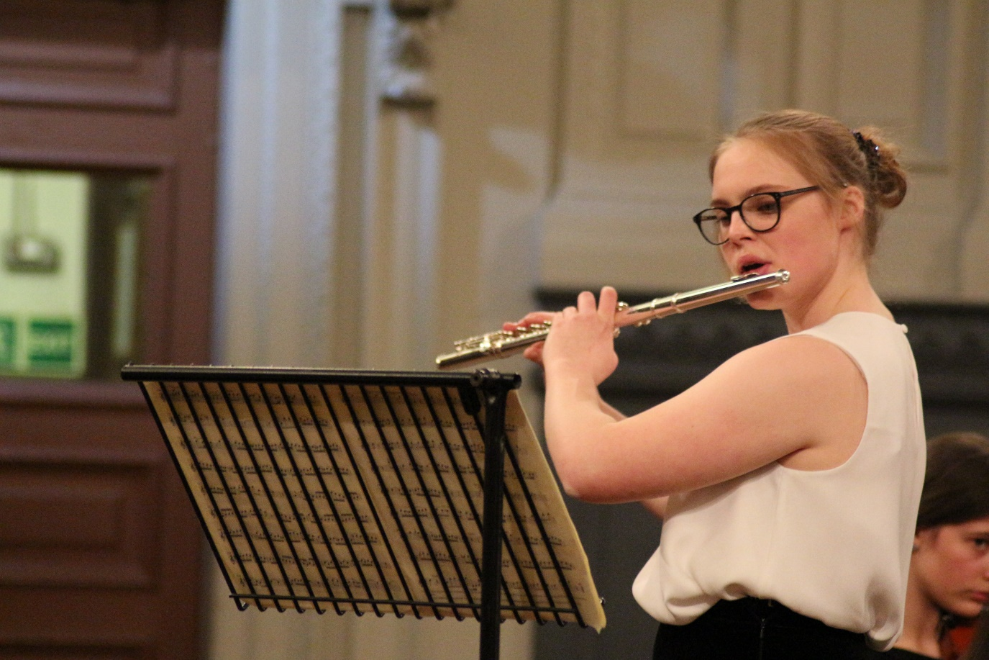
Senior Concert
Sheldonian Theatre
April 2019

