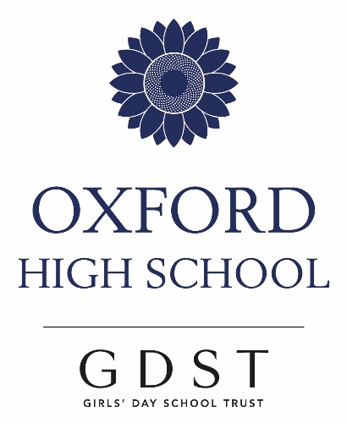

A Level Italian

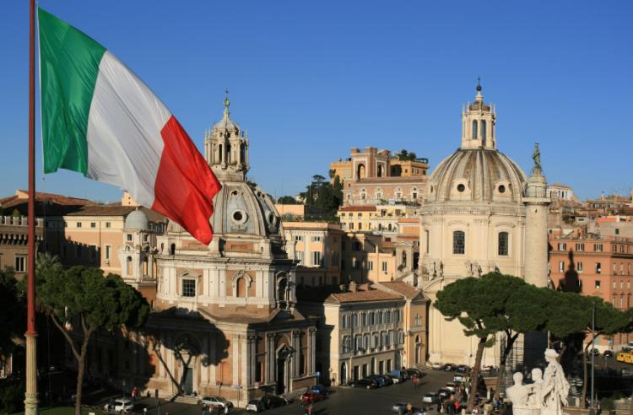

Why choose to study Italian at A Level?
- Italy is the third largest economy in the Eurozone
- Italy is the 8th-largest economy by nominal GDP in the world, and the 12th-largest by GDP (PPP)
- Italy is a founding member of the European Union, the Eurozone, the OECD, the G7 and the G2
- The UK is the 4th largest importer of Italian goods and Italy the 11th importer of UK products
- Fewer schools offer Italian and to have Italian on your curriculum gives you a different and useful skill to offer an employer
- Between 1998 and 2008, Italy produced 371,205 scientific publications, putting the country in 8th position worldwide and 4th in Europe. The predominant fields are medical science, space science, mathematics, and physics
- Over this same period, Italian publications were the 7th most cited internationally (4.16 million) particularly in the fields of molecular biology and genetics, immunology, space science, and neuroscience and behaviour
- Italy has produced a great number of worldwide scientists and Nobel prices for science: Guglielmo Marconi is the inventor of the wireless apparatus; Antonio Meucci is the true inventor of the telephone; Marcello Malpighi made many important anatomical discoveries; Renato Dulbecco won the Nobel prize for cancer research; Galileo investigated the laws of physics and astronomy; Evangelista Torricelli invented the barometer; Leonardo da Vinci was the father of geology; Tartaglia and Cardan discovered the solution of cubic equations; Enrico Fermi created the Fermium; Maria Montessori developed the Montessori System of Instruction
- UNESCO estiamtes that 60% of the world’s art treasures are found in Italy
- Italian culture has influenced European and British culture throughout the ages from the Roman times to the Renaissance
- Much British literature and poetry was directly influenced by Italian culture, plus landscaping and architecture such as The Radcliffe Camera and Saint Paul’s Cathedral were inspired by Italian influences
- Music, cinema, fashion and design are fields of Italian excellence.

What will my A Level Italian course cover?
Specification: Edexcel – Pearson (taught since 2017).
In the Italian A Level course at OHS, you will:
- learn about Italian recent history and Italian contemporary culture and customs.
Themes and subthemes:
- Changes in Italian society
Evolution of the Italian family -changes in attitudes towards marriage; gender and family structures.
Education -the Italian education system and the phenomenon of Brain Drain
Employment -gender equality; unemployment; technological innovation.
- The political and artistic culture in Italy and in Italian speaking countries
Music – changes and development; influence on popular culture
Media – freedom of speech; news online and in print; impact on society and politics.
Cultural heritage – Traditions, feasts, customs.
- Italy as an evolving society
The positive impact of immigration –immigrants’ contribution to the economy and to culture
Problems linked to migration –marginalisation and alienation, integration, impact of emigration
The North/South divide- movement of people between South and North, the role of industry, socio-cultural differences, criminality.
- From Fascism to the Present
Mussolini’s rise to power- the birth of the Fascist Party
Fascism during WW2 – Mussolini’s government and dictatorship; life under Mussolini during the war
From Dictatorship to Democracy – The fall of Mussolini, Resistance and Liberation, 6 EU Nations and the treaty of Rome

- Study a Literary text and a contemporary Film.
You will read and study one of these Literary texts:
● Il giorno della civetta, Leonardo Sciascia, 1961 (novel)
● Io non ho paura, Niccolò Ammaniti, 2001 (novel)
● Jack Frusciante è uscito dal gruppo, Enrico Brizzi, 1994 (novel)
● Lessico famigliare, Natalia Ginzburg, 1963 (novel)
● Marcovaldo, Italo Calvino, 1963 (short stories)
● Sei personaggi in cerca d'autore, Luigi Pirandello, 1921 (play)
● Senza sangue, Alessandro Baricco, 2002 (novel)
● Volevo i pantaloni, Lara Cardella, 1989 (novel)

You will watch and study one of these Films:
● I cento passi, dir. Marco Tullio Giordana (2000)
● Il Postino, dir. Michael Radford (1994)
● La grande bellezza, dir. Paolo Sorrentino (2013
● La vita è bella, dir. Roberto Benigni (1997)
● Nuovo cinema paradiso, dir. Giuseppe Tornatore (1988)
● Va’ dove ti porta il cuore, dir. Cristina Comencini (1996)

- Translate both from Italian and into Italian.
- The language progression from GCSE will be seamless and in lessons you will learn new and more advanced grammar structures and new vocabulary in order to develop your reading, listening, writing and speaking skills.
All this will be achieved using a variety of activities and many media, but above all by always having fun and feeling that you are enjoying your lessons’ exciting pace and interesting content.
Your oral preparation will be supported by specific oral lessons with an Italian Assistant.

*****
Destinations of Italian students in the last few years
Whilst some students have chosen to carry on with Italian at University - sometimes in connection with other languages or sometimes in parallel with another field of study such as Art, Fashion, Music, Architecture, Drama etc. - many have chosen a variety of faculties, for example: Medicine, Biology, Law, English, Drama and Art Foundation courses.

University destinations have included:
- Cambridge
- Bristol
- UCL
- Oxford
- Essex
- Warwick
- St Andrews
- Edinburgh

*****
Co-curricular enrichment
- You will be informed about and will be encouraged to attend lectures, films and plays of Italian nature and interest.

- In Year 12, you will be encouraged to apply for the Dorothy Rowe Trust Award, which is uniquely available to students of Italian at OHS. This award will allow you to have a one-one exchange with a student from a Liceo Scientifico in Pozzuoli (Naples) and you will be able to spend two weeks in Pozzuoli in the Bay of Naples, Covid-19 permitting.

- Other language and co-curricular trips and collaborations (local and in Italy) will be considered when appropriate.

