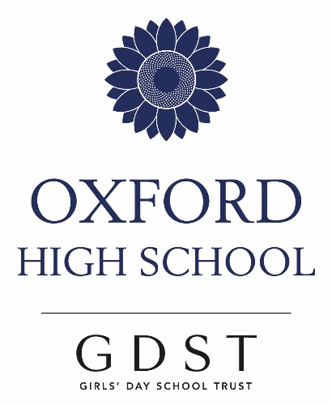

A Level History

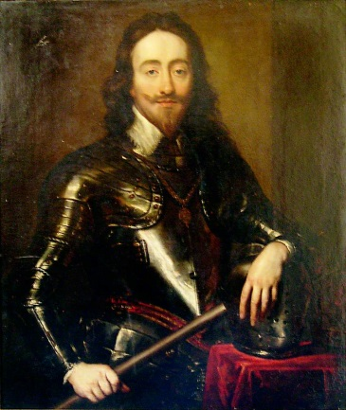

“In grave difficulties, and with little hope, the boldest measures are the safest”

King Charles I

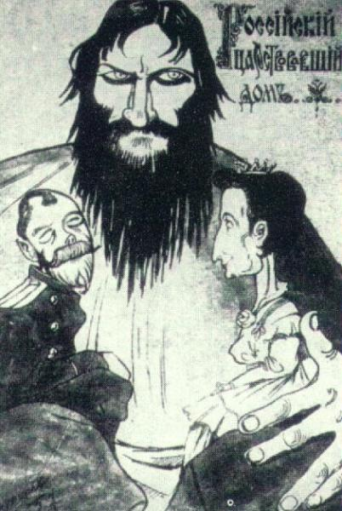

“I am obliged to report that, at the present moment, the Russian Empire is run by lunatics.”

Maurice Paleologue, French ambassador in Russia.

Why study History?

History at Oxford High School is fun, interesting, and rewarding. Your teachers will readily offer support and encouragement. You will find that the skills and knowledge you acquire will prove to be useful in whatever path you choose to follow in the future.

What will I study at A Level?
The exam board is Edexcel and the A Level course changed in September 2015. All exams will be taken at the end of Year 13.

You will pursue an exciting series of topics under the overall title:

Revolutions in early modern and modern Europe

Year of study | Title of Topic | Assessment | Weighting of Unit.
Year 12 | Rebellion and disorder under the Tudors, 1485–1603 | 1 paper: 2 hours 15 minutes | 30%
Year 12 | Russia in revolution 1894–1924 | 1 paper: 1 hour 30 minutes | 20%
Year 13 | Britain, 1625–1701: conflict, revolution and settlement | 1 paper: 2 hours 15 minutes | 30%
Year 13 | Coursework | Coursework | 20%

Coursework:
The course comprises an independent research assignment on historical interpretations, which will be linked to some aspect of Russia in revolution. It requires you to write a 3-4,000 word essay.

Year 12

Rebellion and disorder under the Tudors, 1485–1603
Turbulent years in which there were rebellions across the period both in England and in Ireland.
The course comprises a combination of breadth and depth studies and looks at the various ways the challenges were met. The exam involves 1 source question, 1 depth essay and 1 breadth essay.

Russia in revolution, 1894–1924
A period of complete change which had a momentous effect on 20th century Russia and the modern world.
The course comprises a study in depth of the causes, course and consolidation of the Russian Revolution of 1917. You will look at the end of the Romanov family and Tsarist Russia as well as Lenin and the Bolsheviks. The exam involves 1 source question and 1 essay.

Year 13

Britain 1625-1701
An incredibly exciting time in British History as we experienced a civil war and cut the King’s head off.
The course comprises a study in breadth, in which you will learn about key features of government in Britain. The focus is on developments and changes over a broad timescale 1625–88, as well as a study in depth of historical interpretations on a broad question: How revolutionary, in the years to 1701, was the Glorious Revolution of 1688–89? The exam involves 2 essays and 1 interpretation question.

Key Questions about History A Level

Do I need to have studied History at GCSE?
This is not essential, but it is helpful – the skills required in the Sixth Form build upon those developed at GCSE.

What other subjects work well with History?
This is what makes the Sixth Form so exciting because History goes well with a range of subjects. Many students study it alongside RS, English, Politics, Classics or Modern Languages, but we also have Geographers, Economists, Biologists and future Medics. In other words, it compliments virtually every subject offered at Oxford High.

What are History results like at OHS?
Results at A Level are consistently very good. Over the last 5 years more than 60% of students have achieved A*s in History, and 90% have achieved A/A*.

Where do Historians go to university?
Students choose a range of top universities to study History on its own or they combine it with another subject. Since 2009 these have included:
Birmingham, Bristol, Cambridge, Exeter, Leeds, Liverpool, Nottingham, Oxford, Queen Mary, Sheffield, St Andrews, UCL, York.

Other A Level Historians have gone on to study subjects such as: Classics, English, Geography, Medicine, Psychology, Social Sciences and Law.

