A Level Geography
Few other subjects can provide such a vital forum for exploring the challenges we face today. Geography offers students the opportunity to study a traditional discipline, through issue based enquiry.
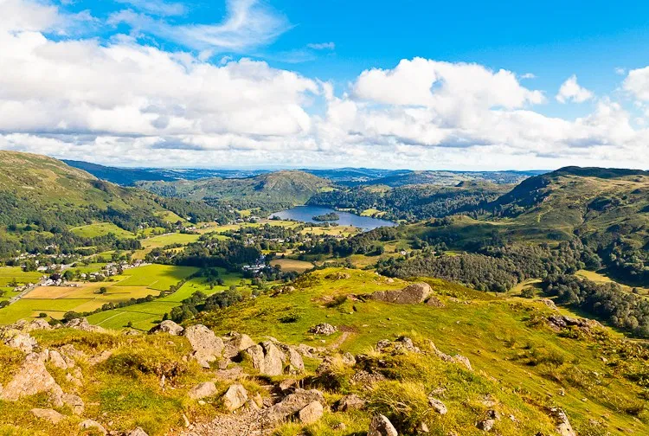
“Geography is the subject which holds the key to our future" - Michael Palin

Geography’s relevance today
Nationally, the number of students taking Geography at A Level remain high and there has never been a more important time to study Geography. It focuses on many pressing issues such as climate change and its impact on both our physical environment and human development, migration and changing population structures, globalisation, development and sustainability ruling the political agenda. Geography is the perfect place to further one’s understanding of the complex interrelationships involved, to ask questions and seek answers.
The strength of the subject
The great Antarctic explorer, Ernest Shackleton, said of his brave expedition team, “strength is in unity”. Geography’s strength comes from its unique ability to bridge the social sciences with earth sciences and unite knowledge from different disciplines to interpret the bigger picture within a spatial context.
You would find a room of geographers able and happy to analyse and evaluate viewpoints as well as scientific data. Geographers can acknowledge bias in sources, produce a strong written argument, offer new ideas, investigate a hypothesis through accurately gathered quantitative data, use statistical tests, and graph skills to reach conclusions. No wonder Geography combines so well with other subjects!
Students and Success
The department has a record of excellent A Level exam results and Geography is consistently a popular choice of degree subject at Oxford High School.
Geography Exam Results Summer 2019
A* | 62.5%
A* - A | 87.5%
A* - B | 100%

Leavers studying Geography at university in the last few years (destination and A Level subjects):

EDINBURGH (Economics, Geography, Spanish)
DURHAM (Economics, Geography, Maths)
QMUL (Chemistry, Geography, Maths)
LEEDS (Biology, English, Geography)
BIRMINGHAM (English, Geography, Music)
CAMBRIDGE (St Catherine’s) (Biology, English, Geography)
CAMBRIDGE (Newnham) (Economics, Geography, Psychology)
DURHAM (Geography, History, Maths)
DURHAM (Geography, History, Maths)
DURHAM (Biology, Geography, English)
DURHAM (Economics, Geography, History)
IMPERIAL COLLEGE (Env Geosci) (Biology, Geography, Maths, Physics)
LEEDS (Music, Geography, Politics)
LEEDS (Economics, Geography, Maths)
LSE (Economics, Geography, Maths)
LSE (Geography, Maths, Physics)
MANCHESTER (French, Geography, Politics)
UCL (Economics, Geography, Maths)
UCL (Biology, Geography, Psychology)
SOUTHAMPTON (Chemistry, Geography, Maths)

Where Geography can take you
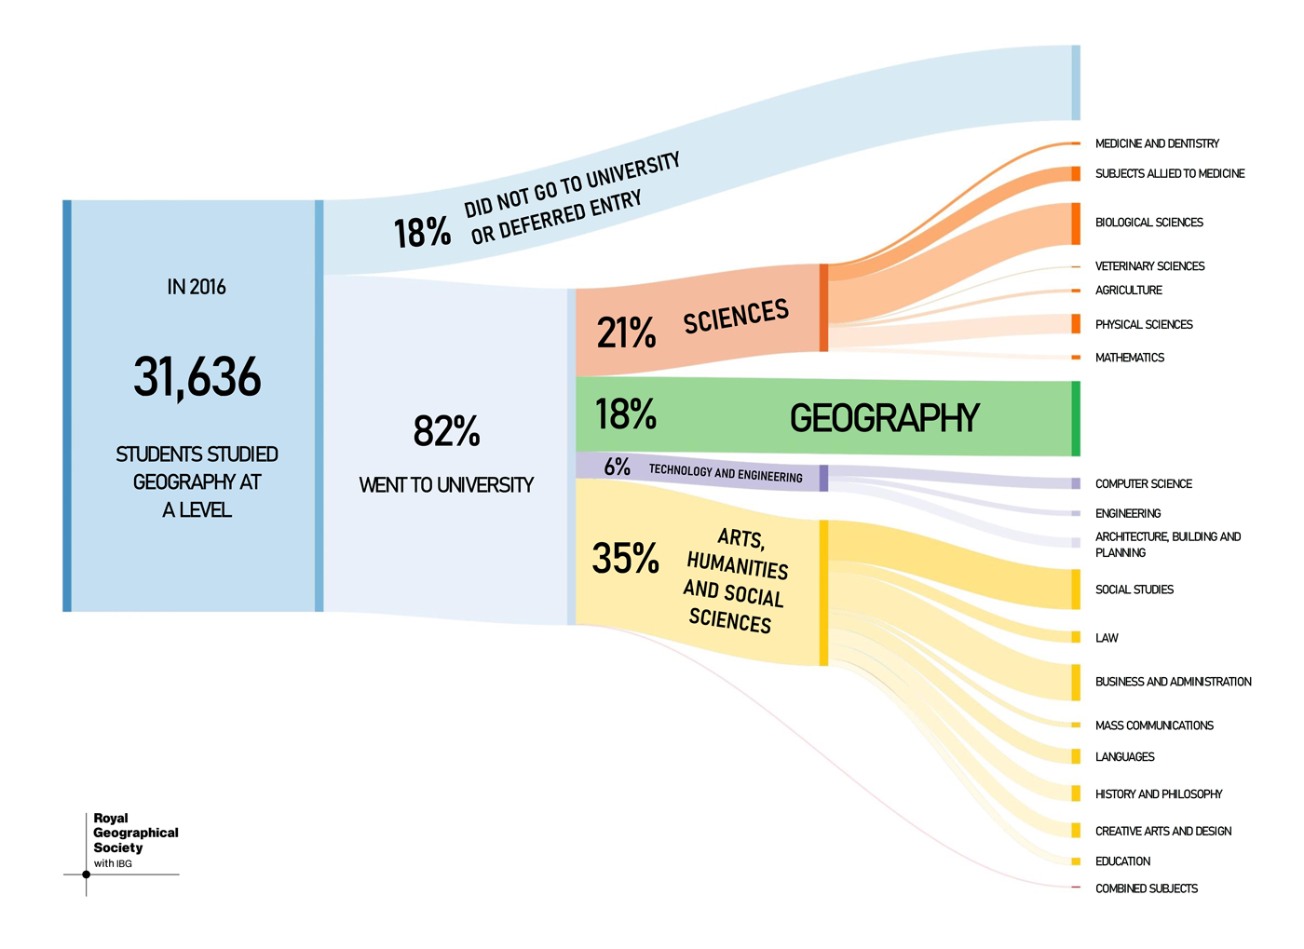
Post A Level Pathways - RGS
Reproduced with permission from the Royal Geographical Society (with IBG) ©RGS-IBG
For students wishing to read Geography at university, it is usually expected that you will have studied it at A Level. For those wishing to take another degree, however, the top UK universities list Geography as a Facilitating or Preferred Subject so it can be one of your chosen A Levels.
Geography develops so many transferable skills (e.g. decision-making, essay-writing, statistical analysis and communication) that it is an attractive option if you wish to keep your options open. The Royal Geographical Society is delighted that entries at A Level are rising as the subject’s relevance increases.
Degree subjects which Geography could lead to:
Anthropology International Relations
Architecture Languages
Biological Sciences Law
Economics Medicine
Geology Politics
Geography Physical Sciences
History Population Studies

Combinations with Geography
The breadth of Geography means that it appeals to people with a wide range of interests. Some students may choose to study Geography alongside traditional sciences; others may choose a Humanities or Arts combination whilst some go for a mixture. (GCSE is helpful, but not essential.)
The Russell Group of universities regard Geography as a Facilitating Subject (with Biology, Chemistry, English Literature, History, Languages, Maths and Physics) and UCL lists it as a Preferred Subject. In 2015 the Guardian identified Geography as the ‘must-have A Level’.
So, choose the subjects you love and Geography will always work!

THE COURSE
AQA Geography 7037
The AQA Geography course is issue based and diverse; allowing students to explore a wide range of different topics. Students are required to use their own wider reading to further their knowledge and understanding of case studies and locational examples to give further evidence and understanding to their work.
The course is examined as follows:
Component 1: Physical Geography | 40%
Component 2: Human Geography | 40%
Component 3: Geography fieldwork investigation  Independent NEA (Non-Examined Assessment) | 20%

Year 12 outline
- Physical Units - Water and Carbon Cycles (major stores at or near the Earth’s surface and their dynamic cyclical relationships) and Coastal Systems and Landscapes (an appreciation of these dynamic environments)
- Human Unit - Changing Places (focuses on students’ engagement with places at a range of scales) and Population and the Environment (exploring the relationships between demographics, health and well-being)

Year 13 outline
- Physical Units – Hazards (volcanic, seismic and atmospheric).
- Human Units – Global Systems and Global Governance (the economic, political and social changes as a feature of global economy and society).
- An individual geographical investigation worth 20% of the A Level

Subject Enrichment
We have close links to the Oxfordshire Geographical Association (GA) and students are encouraged to attend the GA programme of after-school lectures. Upcoming titles that our current A Level students are looking forward to attending virtually include ‘Your place or mine’ on the concept of place, ‘Climate Proof-Cities, Tiny Forest’; the termly programme is always diverse and current, offering lectures on physical, human, political and environmental themes.
We also offer to our A Level students opportunities to enter essay competitions – including the RGS ‘Young Geographer of the Year competition’ and the opportunity to submit their work to the ‘Routes Journal’ – a Geography journal for A Level and Undergraduate geographers.
Many A Level students choose to support the running of the ‘OHS KS3 Geography Club’. This is an excellent opportunity for Year 12 students to share their passions, interests and expertise with students in KS3 – to help inspire another generation of geographers.
At OHS we run a Geography Book Club. Choosing a different book each half term, this club gives students and staff the opportunity to discuss books related to Geography – which in turn is excellent subject enrichment.
Students will also have access to:
- Journal articles on JSTOR
- Geography Review Magazine subscription (electronically through the e-library, and the most recent hard copies in the library and geography department).
- Arc GIS mapping

Field Trips (Covid-19 permitting)
- A 5-day residential trip to Slapton Ley FSC Centre, Devon in May focussing on coastal systems and the concept of place
- A day in Jericho, Oxford examining change to support a detailed case study of the location
- Links with Wytham Wood – exploring the woodland and investigating the Carbon Cycle in more detail
- The opportunity to go on the biennial OHS Iceland trip (next trip anticipated to take place in Summer 2022)

