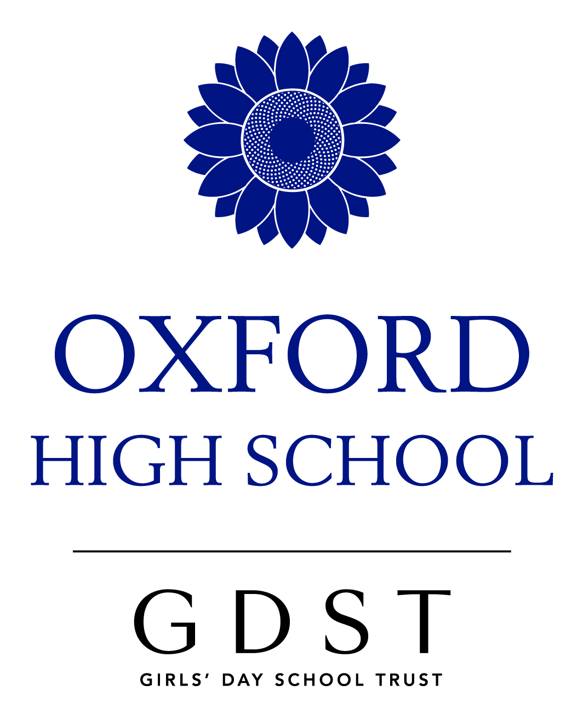

A Level French

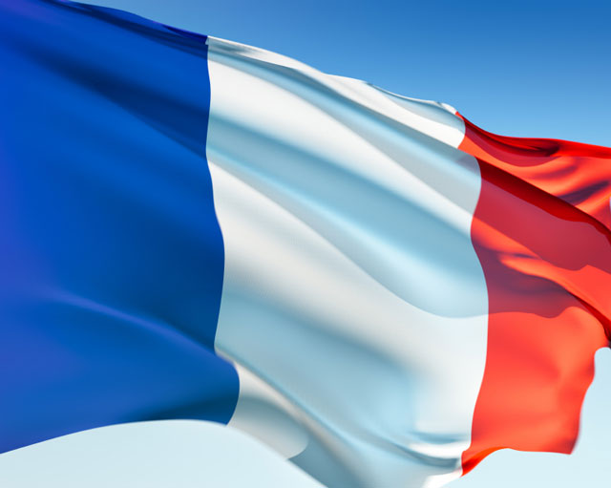

Why choose to study French at A-Level?
- There are currently 67.8 million people with French as their first language, and it is spoken in 60 countries around the world
- French is the only language other than English spoken on five continents. French and English are global languages
- France is the world's largest manufacturer of television sets (HDTV was invented in France)
- The French are leaders in medical genetics
- The French are the world's third manufacturers of electronics equipment
- France is the fourth largest producer of cars in the world
- France is the European leader in aerospace
- France is a major world research centre in the field of high energy physics
- More tourists visit France than any other country in the world
- French, along with English, is the official working language of:-The United Nations, the International Olympic Committee, the International Red Cross, the Council of Europe, the European Court of Justice
- French is the language of philosophers: Sartre, Camus, Proust, Rousseau, Voltaire
- French is the language of poets and love!

Classroom and homework activities in the French Department

The French Department aims to keep the French students up to date with what is going on in France now, hence the use of online resources, magazines and other authentic stimuli. The French library shelves are re-stocked every year (especially after the home stay visit to Angers!) with contemporary and classic works of literature as well as French magazines such as Paris Match and Phosphore.

Activities in class include:

• Debating contemporary issues
• Pair/group work
• Translating (from French into English and from English into French)
• Listening to CDs, podcasts and recordings from French television and radio
• Summarising newspaper and magazine articles
• Watching and commenting on films (cinema and movie studies are part of the A Level syllabus)
• Essay writing about the novel Bonjour Tristesse by Françoise Sagan and a film
• Grammar drills and exercises (often using online resources)
• Vocabulary building using interactive websites
• French Language assistant oral lessons
• Oral presentations in class or recorded

The AQA specification at A Level

Paper 1: Listening, Reading and Writing - Themes: aspects of French-speaking society, artistic culture, multiculturalism, and political life

- 50% of A Level marks | - Taken in June of Year 13
- 2 hour 30 minutes exam paper | - Individual student control of MP3

Paper 2: Writing - one literary text and one film

- 20% of A Level marks | - 2 hour exam paper | - Taken in June of Year 13

Paper 3: Speaking - Discussion of one of the four themes outlined for Paper 1. Presentation and discussion of individual research project

- 30% of A Level mark | - 20 minutes with 5 minutes preparation of a stimulus card
- Taken in April/May | - Conducted by class teacher, marked by AQA

Themes
Aspects of French-speaking society: current trends
- The changing nature of family
- The digital world
- The place of voluntary work

Aspects of French-speaking society: current issues
- Positive features of a diverse society
- Life for the marginalised
- How criminals are treated

Artistic culture in the French-speaking world
- A culture proud of its heritage
- Contemporary francophone music
- Cinema

Aspects of political life in the French-speaking world
- Teenagers, the right to vote and political commitment
- Demonstrations/strikes-who holds the power
- Politics and immigration

Co-curricular activities

- Home stay trip to Angers
- Oxbridge French Literature/Poetry Club in Year 13
- ` Journée Française ` with the Alliance Française for Sixth Form French students with workshops, visit to the Ashmolean in French and lunch in a French café
- After school lectures given by French natives and University lecturers
- Cinema studies as an integral part of the A-Level specification
- Grammar Club (Spring term)
- Translation workshop with a professional translator

