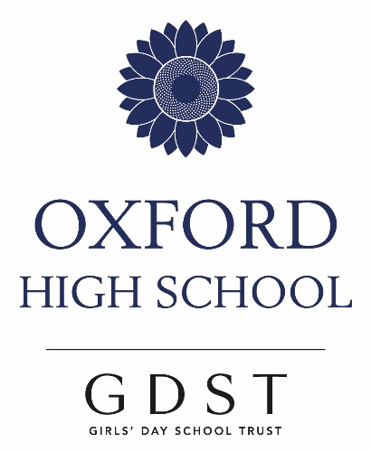

**A Level Classics:  
Latin and Greek**

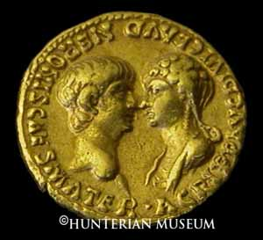

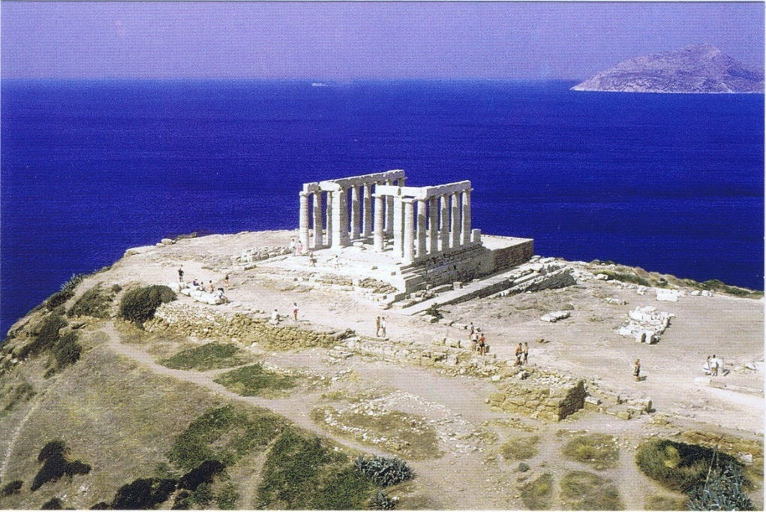

**The Classics Department**

Mr Richard Lonsdale (Head of Department)

Dr Niki Karapanagioti

Dr Claudia Strobel

Ms Victoria Paterson

**Classics is...**

Fascinating, Exciting, Challenging, Varied, Thought Provoking and Logical.

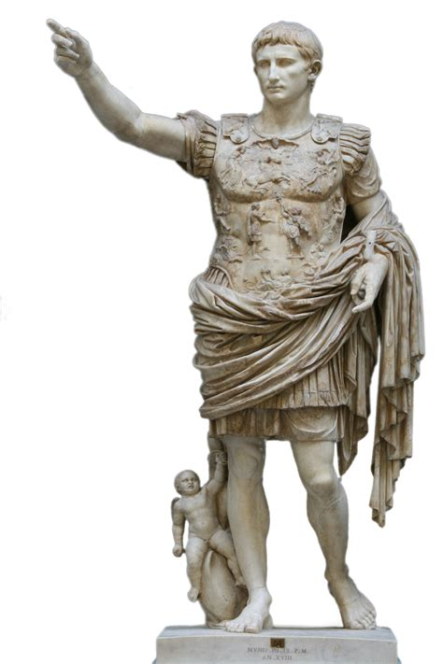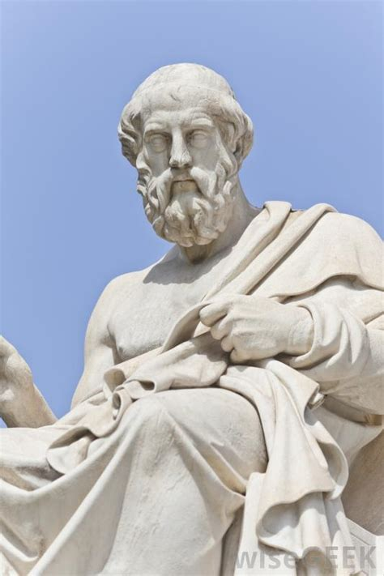

**LATIN AT A LEVEL**

**Why study Latin?**

There is a real **intellectual challenge** in studying the language and literature of the Romans. Let’s face it, their language is just more detailed than our modern uninflected versions. We exercise our minds considerably if we make them grapple with cases and moods and genders. Once the language is grasped, what a **treasure trove of beautiful literature** opens up. This ranges from Catullus’ love poetry through Vergil and Horace to Ovid; from Caesar out in the fields of Gaul to Cicero in full rhetorical flow in the Roman Forum; we have Livy telling of Hannibal and his elephants, Tacitus of the villainous Nero plotting against his own mother. We start to understand **the foundations of European literature and thought** and the way that the Renaissance brought these things back to us.

**Who can do it?**

**Anyone who wishes to do so**. There are no restrictions on what combines with Latin, although some subjects are more obvious companions than others – e.g. English, because you can compare literatures; History, since you learn some earlier history and apply your analytical skills to earlier evidence; modern languages – Latin is the basis for French, Spanish and Italian, while German is also inflected (although a different part of the Indo-European tree). Of course, you need to enjoy the process of learning the language before you embark on more of it.

Numbers in recent years have been excellent with **43** girls studying A Level Latin in the last six years.

**The A Level exam:**

The preliminary aim is to establish **reading fluency** rapidly, using several different books. To start with we read non-exam extracts from Ovid, Livy (a historian) and Caesar. After about six weeks, we **begin the set texts** – four selections of literature, two prose and two verse. In the first year, the texts will be taken from **Virgil Aeneid XI**, and part of one of **Cicero**’s speeches against Anthony in **Philippics II***.* In addition to reading literature, we build up understanding of the **background,** researching and discussing many angles of this culture on which modern European life is based.

We have also had great success at **Oxbridge** entry with 11 girls gaining places in the last seven years.

**GREEK AT A LEVEL**

**Who studies Ancient Greek?**

A surprisingly large number of students study Greek at OHS! First and foremost, you need to find the ideas and literature of the Ancient Greeks fascinating. The language work is intense and yes, you do need to **enjoy grammar and translating**. As with Latin, there are four set texts. Next year, we will be reading extracts from Plato’s Phaedo and Euripides’ Medea.

Numbers in recent years have been good with 23 girls studying A Level Greek in the last six years.

**Must I have done GCSE Greek?**

Ideally students who opt for Greek A Level will have taken a GCSE in Greek, but sometimes students realise **later on** that they want to study Greek, and we have had four students in the last four years who have started to study Greek **in Year 12** and successfully taken GCSE and A Level exams. There is a wonderful Greek Summer School at **Bryanston** (two weeks long, at the end of July), where students are immersed in Greek morning to night, with lectures and plays and concerts, as well as social fun and games. Students who are keen on Greek come from all over the country (about 300 of them), both beginners and A Level students. Some people become addicted and go on the course twice, for fun!

**The new A Level exam from 2018:**

The preliminary aim is to establish **reading fluency** rapidly, using several different books. To start with, we read non-exam extracts from Xenophon, Lysias and Herodotus. After about six weeks, we **begin the set texts** – four selections of literature, two prose and two verse. In the first year, the texts will be taken from **Plato’s Phaedo**, and **Euripides’ tragedy, Medea***.* In addition to reading literature, we build up understanding of the **background,** researching and discussing many angles of this culture on which modern European life is based.

**What else is there to do with Classics?**

* Come to Italy or Greece! Our Classical trips run in October half-term every two years and we love to have Sixth Formers come on these.
* We also take students to day conferences (one each year) and we often go to see Ancient drama – in October, we are going to see the Cambridge Greek Play.
* Our senior Classics club, run jointly by students and teachers, invites speakers in to extend ideas beyond the lessons and specification. We have enjoyed talks about tragedy, the origins of language, Roman battles to name a few.
* Classical Book Club run by Mr Lonsdale reads and discusses a contemporary novel based on a classical theme. Recent books discussed have been The Silence of the Girls and the Penelopiad.
* Sixth Formers also help to run the junior Classics club – gory stories, model making, drama, feasts.

**Where do Latin and Greek lead?**

Latin and Greek, or either one on its own, can be the **main focus** of your university application, or it can be **combined** with many humanities subjects for joint honours (eg History, English, a modern language, Philosophy). **Reading Classics** at University is wonderful fun and endlessly varied. It is a growth area among the Humanities - there are fantastic **Classics courses** at most universities and Latin students can even start Greek there. **Classics extends into countless areas** – ancient history, archaeology, vase painting, sculpture, philology, text rebuilding (from eg fragments of papyrus), philosophy, as well as the main-line languages and the massive bank of literature. You can investigate wide-ranging social issues too: **Gender** – why were women so suppressed yet feared? **Slavery** – how could the philosophers live with, even defend, such a system? **Sex** – were they obsessed with it, or are we just rather prudish? **Death and murder** – very different attitudes, then and now. So the list goes on. Latin or Greek can however also be **high-quality support** subjects for e.g Medicine, Maths, Physics, Engineering. Its **rigorous language requirement** make them A Levels much respected by all.

We have also had great success at **Oxbridge** entry with eleven girls gaining places to study Classics in the last seven years.

**What about the actual specifications?**

**Latin**

<https://www.ocr.org.uk/Images/220734-specification-accredited-a-level-gce-latin-h443.pdf>

**Greek**

<https://ocr.org.uk/Images/220709-specification-accredited-a-level-gce-classical-greek-h444.pdf>

A Level Latin and Greek have four papers taken after two years in the summer of 2022. Two deal with language, asking students to translate from the language into English. There is an option to write sentences in the language too. The two literature papers extend from the known GCSE model, taking four set books and asking about all aspects of the style and content. There is translation there too, but this time prepared.

**1) Language – two papers with prose and verse translation and comprehension -** More vocab and grammar than at GCSE! Translation and comprehension from Latin to English/Greek to English.

**2) Verse and Prose Literature- two papers -** Candidates develop their language skills through a study of prescribed verse and prose texts, such as the works of Plato and Euripides/Virgil and Cicero. Candidates will demonstrate understanding of literary techniques and have the opportunity to make a personal response to the texts in answers to questions and in essays.

**What’s the work load like?**

There is a lot to do, as with all subjects. Lessons are shared between two/three teachers, separating the syllabus into parts. The weekly work falls into chunks – new grammar, vocab learning, translating of texts, learning the texts. There are not long reading lists for essays, but you do get the chance to write sensitively about literature as your grasp of reading it grows.

**SIXTH FORM EXTENSION ACTIVITIES**

**Digital Resources**

We use many online resources at A Level including:

Massolit – an online resource that works with academics from the world's best universities to produce **high-quality, curriculum-linked** videos for GCSE, A Level and the International Baccalaureate. <https://www.massolit.io/>

Omnibus Magazine – A site that has thousands of articles especially written for Sixth Form students <https://www.classicstuition.com/omnibus-magazine/>

**Plays, Museums, Archaeology**

Covid-19 permitting, any Classical plays that are within striking distance we try to attend, and we encourage students to go to Museums whenever they can. Several students have gone on to attend various archaeological digs as volunteers in the summer holidays.

**The Senior Classics Club**

Over the last two years, the Classics Department, with Dr Strobel’s help and organisation, has hosted many speakers from the University and from the parent body in the lunch hour. These talks are open to other schools and to any students at OHS – as you see from the titles below, the subject matter is not syllabus based!

* Dr Armand D’Angour (Jesus College, Oxford) – Ancient Greek Music
* Dr Felix Budelmann (Magdalen College Oxford) - Sappho
* Dr Llewelyn Morgan (Brasenose College, Oxford) - “Sex, Death and Metrics”, Roman poetry metrical forms and how they can be meaningful.
* Dr Philomen Probert (Oxford Classics Faculty) - Introduction to philology
* Dr Linda Covill - An Introduction to Sanskrit
* Professor Gregory Hutchinson (Exeter College, Oxford) Virgil Aeneid 4 & 12: Words and the Mind
* Donncha O’Rourke (Corpus Christi College) - an introduction to Ovid’s Elegy

**Sixth Form Conferences**

Covid-19 permitting, we also attend three events each year – a Literature Conference for Greek and Latin Literature and the Classical Reading Competition.

**Visits Abroad**

We offer a rolling series of visits to classical sites abroad for students in Years 9 to 13. Every two years we shall visit Italy or Greece.

**October 2021 Greece** (depending on COVID conditions)

**October 2019 Sicily –** Syracuse, Agrigento, Palermo, Taormina, Segesta.

**October 2017 Greece –** Athens, Delphi, Olympia, Sounion, Mycenae, Nauplion, Corinth, Nemea, Epidauros, and Tiryns.

**October 2015 Southern Italy –** Pompeii, Herculaneum, Oplontis, Paestum, Cumae, Baia, Solfatara, Capua, Napoli

**October 2013 Greece** – to Athens, Vravrona, Sounion, Elevsina, Delphi, Hosios Loukas, Mycenae, Tiryns, Nemea, Epidauros, Argos, Nauplion and Corinth.

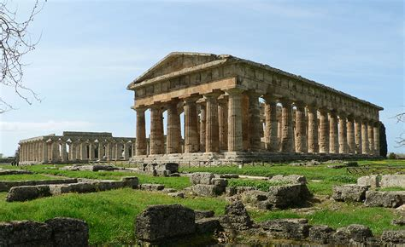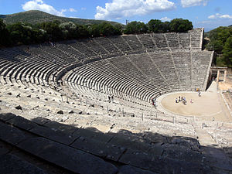

**Classics at University: UNIVERSITY DESTINATIONS**

**2020** Cambridge King’s

Edinburgh

**2019** Harvard

**2018** Oxford Oriel

Cambridge Pembroke

Durham

**2017** Oxford University

St Andrews

**2016** Cambridge Sidney Sussex

[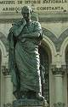](http://images.google.co.uk/imgres?imgurl=http://www.uni-konstanz.de/FuF/Philo/LitWiss/latinistik/aktuelles/ovid.png&imgrefurl=http://www.uni-konstanz.de/FuF/Philo/LitWiss/latinistik/aktuelles/ovidtagung.htm&h=409&w=262&sz=462&hl=en&start=7&tbnid=IR4MvPGWYYC-tM:&tbnh=125&tbnw=80&prev=/images?q%3DOvid%26svnum%3D10%26hl%3Den%26lr%3D)

**2015**  Oxford St Hilda’s

St Andrews

**2014**  Oxford Trinity

**2013**  Oxford Corpus Christi

St Andrews

Cambridge Gonville & Caius

Durham

**2012**  Oxford Corpus Christi

Cambridge Magdalene

**2011** Cambridge Emmanuel

Oxford Magdalen

Durham